**DATA ANALYTIC TECHNIQUES USING ELASTICSEARCH, HADOOP, KIBANA AND AMAZON WEB SERVICES**

by

Likhita Sanapa Prabhakar

Bachelor of Technology, 2013, JNTU, Hyderabad, India

A Project Submitted to the Faculty of

Norfolk State University in Partial Fulfillment of the

Requirements for the Degree of

MASTER OF SCIENCE

COMPUTER SCIENCE

NORFOLK STATE UNIVERSITY

SEPTEMBER 2017

Approved by:

________________________________

Dr. George Hsieh (Director)

________________________________

Dr. Yen-Hung Hu (Reviewer)

# ABSTRACT

Data Analysis and Management is an increasingly important process in today’s business world, to gain insights and competitive advantages. There are many tools used for analyzing and managing logs.

Elasticsearch is a powerful distributed search and analytics engine developed in Java and built on top of Lucene. It is a free and open source search engine which can perform full-text search. Kibana is an open source visualization tool, often used along with Elasticsearch, to create visualizations from the indexed data on Elasticsearch cluster and provide useful insights especially from large volumes of data.

For scalability, Apache Hadoop is commonly used with Elasticsearch for immense data storage and huge processing power. For public cloud based computing environments, Amazon Web Services (AWS) is a very popular platform providing Elasticsearch and Kibana capabilities.

This Master’s Project research was focused on analyzing and managing data using Elasticsearch, Kibana, Hadoop, and AWS. First, we implemented a (pseudo-distributed-mode) Hadoop cluster, configured with Elasticsearch and Kibana using the ES-Hadoop library, on a local Linux workstation. Next, we developed data pipelines between Elasticsearch and commonly used Hadoop data analytic tools (i.e., Pig and Hive) to facilitate seamless data collection, storage and search. Then, we developed a Twitter Trend Analyzer to perform real-time analysis of selected tweets from the Twitter application, while using Apache Storm to stream the Twitter feed.

In addition, we developed a real-time web server log analyzer on AWS, using the various data analytic tools made available on AWS, including Elasticsearch for full-text search and Kibana for data visualization.

# ACKNOWLEDGEMENT

I would like to express my sincere gratitude to my advisor Dr. Hsieh for all his assistance and guidance. The research topic for this project was suggested by Dr. Hsieh and I appreciate the opportunity given to me to work on this project. I would also like to thank Dr. Yen-Hung Hu, for being my reviewer.

# TABLE OF CONTENTS

ABSTRACT ii

ACKNOWLEDGEMENT iii

TABLE OF CONTENTS iv

LIST OF FIGURES vi

1. INTRODUCTION 1

1.1 Project Goal 1

1.2 Report Organization 3

2. ELASTICSEARCH USING HADOOP 4

2.1 Setting up Environment 4

2.1.1 Java Setup 4

2.1.2 Dedicated User 4

2.1.3 Hadoop for Elasticsearch 5

2.1.4 Environment Variables 5

2.1.5 Hadoop Configuration 6

2.1.6 Elasticsearch Setup 9

2.1.7 Testing and Results 12

2.1.8 Data in Head and Marvel 15

2.2 Getting Started with ES-Hadoop 17

2.2.1 Pushing Data from Elasticsearch to HDFS 18

2.2.2 Testing and results 20

2.3 Elasticsearch and Kibana 21

2.3.1 CRUD 21

2.3.2 Kibana Setup and Visualizations 24

2.4 Real-Time Analytics 34

2.4.1 Apache Storm 34

2.4.2 Twitter Trend Analyzer 39

2.4.3 Kibana Visualizations 40

2.5 Hadoop Ecosystem 41

2.5.1 Pig with Elasticsearch 42

2.5.2 Elasticsearch with Hive using SQL 45

3. ELASTICSEARCH USING AWS 49

3.1 AWS Account 49

3.2 Architecture 50

3.3 EC2 Instance 50

3.4 Log Files 54

3.5 Kinesis Firehose Delivery Stream 55

3.6 Kinesis Agent 56

3.7 ES Domain 57

3.8 Second Kinesis Firehose Delivery Stream 58

3.9 Kinesis Analytics Application 61

3.10 Kibana 65

4. CONCLUSION 68

5. FUTURE WORK 69

REFERENCES 70

# LIST OF FIGURES

Figure 2‑1: Java Installation 4

Figure 2‑2: bashrc File 6

Figure 2‑3: Hadoop Version 7

Figure 2‑4: core-site.xml File 7

Figure 2‑5: hdfs-site.xml File 7

Figure 2‑6: yarn-site.xml File 8

Figure 2‑7: mapred-site.xml File 8

Figure 2‑8: Starting Hadoop dfs Daemons 9

Figure 2‑9: Starting Hadoop yarn Daemons 9

Figure 2‑10: Command to check the status of Daemons 9

Figure 2‑11: Cluster Name in elasticsearch.yml File 10

Figure 2‑12: Node Name in elasticsearch.yml File 10

Figure 2‑13: Updating Paths in elasticsearch.yml File 11

Figure 2‑14: Starting Elasticsearch 12

Figure 2‑15: Snippet of sample.txt File 12

Figure 2‑16: Snippet of Mapper Class 12

Figure 2‑17: Snippet of Reducer Class 12

Figure 2‑18: Running Maven Command 13

Figure 2‑19: sample.txt File in HDFS 13

Figure 2‑20: Running sample.txt File 13

Figure 2‑21: Output of sample.txt File 14

Figure 2‑22: Home Page of Head Plugin 15

Figure 2‑23: Marvel Dashboard 16

Figure 2‑24: Marvel-Sense Dashboard 17

Figure 2‑25: Twitter Dataset 18

Figure 2‑26: Tweets2ESMapper Class Snippet 18

Figure 2‑27: Running tweets2es Jar File 18

Figure 2‑28: Tweets2hdfsMapper Class Snippet 19

Figure 2‑29: Running tweets2hdfs Jar File 19

Figure 2‑30: Results of Twitter Data 20

Figure 2‑31: Tweets data in HDFS 21

Figure 2‑32: Verifying the Tweet Content 21

Figure 2‑33: Creating Index in Elasticsearch 22

Figure 2‑34: Retrieving Data from Elasticsearch Index 22

Figure 2‑35: Updating Elasticsearch Document 22

Figure 2‑36: Deleting Data from Elasticsearch Index 23

Figure 2‑37: Output of Mappings 23

Figure 2‑38: Kibana Installation 25

Figure 2‑39: Snippet of Consumer Complaints Data 25

Figure 2‑40: Mapper Class Snippet 26

Figure 2‑41: Running the Complaints Jar File 26

Figure 2‑42: Output of the Jar File 27

Figure 2‑43: Kibana Interface 28

Figure 2‑44: Visualization of the Consumer Data 28

Figure 2‑45: Visualization Options on Kibana 29

Figure 2‑46: Visualization of Consumer Complaints on Kibana Pie Chart 30

Figure 2‑47: Stacked Bar Chart Visualization of Consumer Complaints 31

Figure 2‑48: Histogram Visualization of Consumer Complaints 31

Figure 2‑49: Area Chart Visualization of Consumer Complaints 32

Figure 2‑50: Split Pie Chart Visualization of Consumer Complaints 32

Figure 2‑51: Sun Burst Chart Visualization of Consumer Complaints 33

Figure 2‑52: Geographical Chart Visualization of Consumer Complaints 33

Figure 2‑53: Zookeeper Installation 34

Figure 2‑54: Storm Configuration 35

Figure 2‑55: Starting Zookeeper 35

Figure 2‑56: Starting Nimbus 35

Figure 2‑57: Starting Supervisor 36

Figure 2‑58: Starting Storm UI 36

Figure 2‑59: Command to Check the Status of Daemons 37

Figure 2‑60: Storm UI 37

Figure 2‑61: Snippet of Spout 38

Figure 2‑62: Snippet of Bolt 38

Figure 2‑63: Twitter App 39

Figure 2‑64: Creating Twitter Application 39

Figure 2‑65: Running the Storm Job 40

Figure 2‑66: Output of Twitter Streaming Data 40

Figure 2‑67: Twitter Data on Kibana 41

Figure 2‑68: Pig Installation 42

Figure 2‑69: Grunt Shell 42

Figure 2‑70: Installing ES-Hadoop Jar File 43

Figure 2‑71: Loading Crime Data to Elasticsearch Index 44

Figure 2‑72: Results of Crime Data 44

Figure 2‑73: Reading Data from Elasticsearch 44

Figure 2‑74: Results in Elasticsearch 45

Figure 2‑75: Hive Installation 45

Figure 2‑76: Hive Console 46

Figure 2‑77: Creating Table in Hive 46

Figure 2‑78: Target Table 47

Figure 2‑79: Inserting Data into Crimes Table 47

Figure 2‑80: Creating Hive Table for theft_crimes 48

Figure 2‑81: Results from the Requested Query 48

Figure 3‑1: Creating AWS Account 49

Figure 3‑2: Data Analytics Architecture in AWS 50

Figure 3‑3: Creating IAM User 50

Figure 3‑4: Creating IAM Group 51

Figure 3‑5: Creating Key Pair 51

Figure 3‑6: Private Key Pem File 51

Figure 3‑7: Creating Security Group 52

Figure 3‑8: Creating IAM Role 53

Figure 3‑9: Choosing the Key Pair 53

Figure 3‑10: PuTTY Configuration: Session 53

Figure 3‑11: PuTTY Configuration: Authentication 54

Figure 3‑12: EC2 Console 54

Figure 3‑13: Python Code Snippet for Apache Access Logs 55

Figure 3‑14: Command to Run the Python Code 55

Figure 3‑15: Creating Kinesis Firehose Delivery Stream 55

Figure 3‑16: Creating S3 Bucket 56

Figure 3‑17: agent.json File 56

Figure 3‑18: Restarting aws-kinesis-agent 56

Figure 3‑19: Logs in S3 Bucket 57

Figure 3‑20: Data Monitoring from Firehose 57

Figure 3‑21: Creating Elasticsearch Domain 58

Figure 3‑22: Setting Up Access Policy 58

Figure 3‑23: Creating Second Kinesis Firehose Delivery Stream 59

Figure 3‑24: Creating Destination and S3 for Second Delivery Stream 60

Figure 3‑25: Configuration Settings 61

Figure 3‑26: Creating Kinesis Analytics Application 62

Figure 3‑27: Connecting to a Source 62

Figure 3‑28: Streaming Data from Kinesis Analytics 62

Figure 3‑29: SQL Command to Generate Real-Time Logs 63

Figure 3‑30: Real-Time Analytics 63

Figure 3‑31: Storing Streaming Data to Second Firehose Destination Stream 64

Figure 3‑32: Monitoring Real-Time Data from Elasticsearch Service Domain 64

Figure 3‑33: ES Domain Page 65

Figure 3‑34: Creating an Index Pattern on Kibana 65

Figure 3‑35: Configuring the Aggregations on Kibana for Visualization 66

Figure 3‑36: Configuring the Aggregations on Kibana for Visualization 66

Figure 3‑37: Kibana Visualization for Streaming Real-Time Data 67

# 1. INTRODUCTION

Data analysis is an art and science which makes sense of digital data. It is performed for many reasons such as security policy, compliance regulations, troubleshooting a system, forensics, analyzing online customer behavior. Data analysis makes it easy in problem solving, diagnosis and resolution time.

Data management is a process of collecting, administering, transmitting, storing, archiving, monitoring, documenting, etc. large volumes of data in a system. Suppose a web server is maintaining log files recording each request made to the server, the log file analysis and management tools provide a better understanding of what the logs mean, source of where they come from, customers to the website, where these customers are coming from, how frequently they visit, and how the visitors navigate to a website. Enabling cache and cookies logs more comprehensive details about how a user access the site.

Elasticsearch is a powerful distributed search and analytics engine developed in Java and built on top of Lucene. It is a free and open source search engine which can perform full-text search. Kibana is an open source visualization tool, often used along with Elasticsearch, to create visualizations from the indexed data on Elasticsearch cluster and provide useful insights especially from large volumes of data.

For scalability, Apache Hadoop is commonly used with Elasticsearch for immense data storage and huge processing power. For public cloud based computing environments, Amazon Web Services (AWS) is a very popular platform providing Elasticsearch and Kibana capabilities.

## Project Goal

The goal of this Masters Project research is to learn and experiment on how data analysis works. The research project is divided into two parts: 1) Elasticsearch using Hadoop, and 2) Elasticsearch using Amazon Web Services (AWS).

The first part involves the setup of a local workstation running the CentOS 7 operating system, installation of a single-node Hadoop cluster on the local workstation, and installation of all necessary tools for performing analysis using Elasticsearch on Hadoop.

We gathered all the required dependencies in the Hadoop class path to run the Hadoop JAR file. Once we have the data file (it may be any data, in any format like .txt, or .csv) and the JAR file, import the data into HDFS and run the job jar file. In this process of importing and running the job in HDFS, the data is extracted into Elasticsearch with the help of ES-Hadoop library and is visualized through Kibana.

The data can also be imported from Elasticsearch to HDFS by initially loading the dataset to Elasticsearch using the job JAR file and then running the JAR file to load the data from Elasticsearch to HDFS output file location. Here MapReduce jobs are used to acquire the data in and out between Elasticsearch and Hadoop. This is the general process of how to use Elasticsearch and Hadoop locally, analyze data from the input provided, index the data and visualize it. It requires interactions between Elasticsearch and Hadoop platform and tools.

The second part of this Masters Project research focuses on developing a log analytics solution on AWS which includes

* EC2 instance (used as a web server and log producer),
* Amazon Kinesis Firehose Delivery Stream (used to deliver real-time streaming data to destinations such as S3 (Simple Storage Service) and Elasticsearch),
* Amazon Kinesis Agent (It is a stand-alone Java software which offers an effortless way to collect and send data to Firehose),
* Elasticsearch service (used for analysis and visualizations),
* Amazon Kinesis Analytics Application (to aggregate data from streaming web log data and store it in ES), and
* Amazon Kinesis Firehose Delivery Stream to get the output data from Analytics Application to ES.

Here a Python program is developed to produce logs into AWS. An end-to-end pipeline/workflow that combines several AWS services is constructed to ingest the streaming log data, aggregate it in such a way that it can be analyzed and visualized. Then a live stream of Apache access log data is analyzed and the total request for each HTTP response type is aggregated for every minute. And the near real-time data is visualized using Kibana.

## Report Organization

The project report is organized as below.

* Section 2: Elasticsearch using Hadoop
* Section 3: Elasticsearch using AWS
* Section 4: Conclusion
* Section 5: Future work

# ELASTICSEARCH USING HADOOP

A CentOS 7 server is configured to run Hadoop and Elasticsearch, and a wordcount example for testing purpose. Mapper and Reducer classes are implemented for the wordcount example.

## Setting up Environment

We created an environment with ES-Hadoop up and running. In this project, we used a Pseudo-Distributed Hadoop cluster mode on the CentOS 7 server. In this mode, every component runs in its own Java Virtual Machine process to provide the same functionality as in a multi-node Hadoop cluster, without the extra complexity and hardware resources required for the multi-node configuration.

### Java Setup

Java is a required setup for the Elasticsearch Hadoop environment. To setup Java first update the java repository and environment variables using the below commands:

$ sudo yum update

$ sudo yum install oracle-java8-set-default

Java installation is verified as follows:

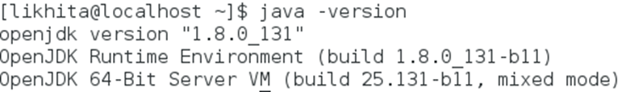

Figure ‑: Java Installation

### Dedicated User

To ensure a smooth and isolated ES-Hadoop environment and enforce security permissions, a dedicated user with a password is setup. First a Hadoop group is added and then a user is added to the group:

$ sudo groupadd hadoop

$ sudo useradd -G hadoop eshadoop

Now login to the eshadoop account and add eshadoop user to the sudoers file:

$ su -likhita

Open the sudoers file which is located at /etc and make the changes on root and user to be able to run any commands anywhere.

$ sudo vi /etc/sudoers

likhita ALL=(ALL) ALL

eshadoop ALL=(ALL) ALL

To save the file press Esc + :wq and update the repository.

### Hadoop for Elasticsearch

Download and extract Hadoop files to /usr/local.

$ sudo wget <http://mirror.nohup.it/apache/hadoop/common/hadoop-2.7.3/hadoop-2.7.3.tar.gz>

$ sudo tar vxzf Hadoop-2.7.3.tar.gz -C /usr/local

Then the Hadoop directory is renamed and the owner is changed to eshadoop user and Hadoop group for all files:

$ sudo mv Hadoop-2.7.3 hadoop

$ sudo chown -R eshadoop:hadoop Hadoop

### Environment Variables

We setup the environment variables in this step. In order to do that we need to edit the .bashrc file as below:

Figure 2‑2: bashrc File

After updating the .bashrc file, we should run the below command:

$ source ~/.bashrc

### Hadoop Configuration

Now set up the JAVA_HOME environment variable in the Hadoop-env.sh file which is located at /usr/local/hadoop/etc/hadoop. The JAVA_HOME variable is updated as:

$ sudo vi /usr/local/hadoop/etc/hadoop/hadoop-env.sh

$ export JAVA_HOME=/usr/lib/jvm/java-1.8.0-openjdk-1.8.0.132-2.b11.el7_3.x86_64/jre

Now, we can check the Hadoop configuration:

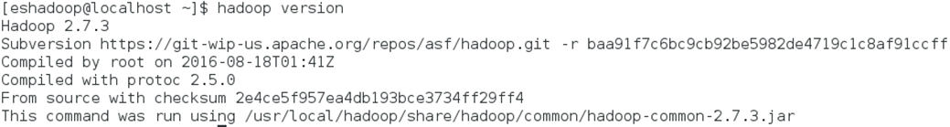

Figure ‑: Hadoop Version

As mentioned previously, we want to install Hadoop in the pseudo-distributed mode with each daemon running in a distinct java process. So, we need to modify the Hadoop system configuration files which are located at:

$ cd /usr/local/hadoop/etc/hadoop

* **core-site.xml:** This creates a temporary directory for Hadoop and a default filesystem. In our scenario, the default filesystem is Name Node. The configuration file for core-site.xml is:

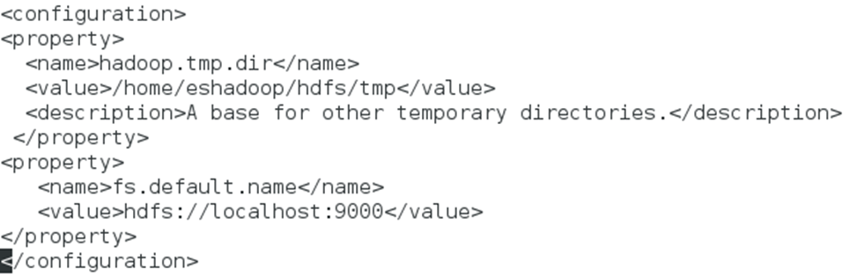

Figure ‑: core-site.xml File

* **hdfs-site.xml:** Configure the replication factor for HDFS with a replication value of 1.

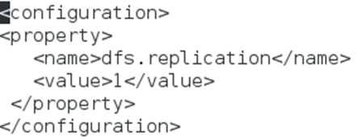

Figure ‑: hdfs-site.xml File

* **yarn-site.xml:** Here the auxiliary service name and classes are configured.

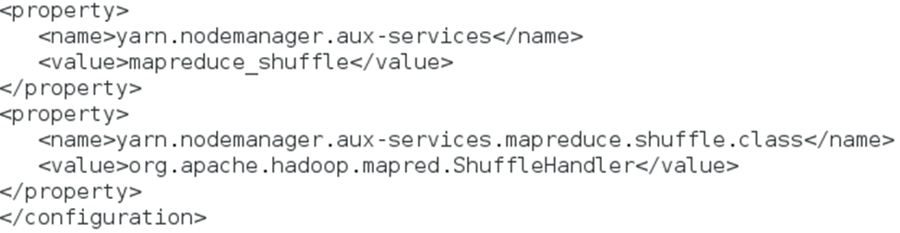

Figure ‑: yarn-site.xml File

* **mapred-site.xml:** This configuration ensures the MapReduce jobs to run on YARN.

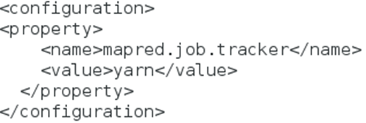

Figure ‑: mapred-site.xml File

HDFS depends on NameNode and DataNodes. NameNode consists of storage-related metadata and DataNode consists of real data stored in the form of blocks. After completion of the Hadoop daemons configurations, it is necessary to format the NameNode before the HDFS is started. The format should be done only at the initial setup, if we do it later then the data in DataNode should be backed up else it will be inaccessible.

$ hadoop namenode -format

Now the Hadoop daemons are started using two commands. The first command is start-dfs.sh which starts the NameNode, SecondaryNameNode and DataNode daemons. The second one is start-yarn.sh which starts ResourceManager and the NodeManager daemons.

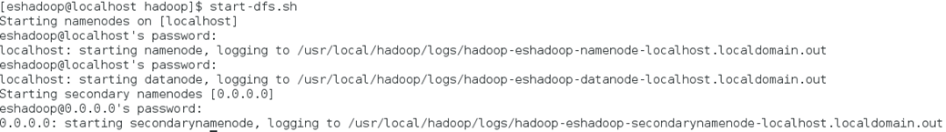

Figure ‑: Starting Hadoop dfs Daemons



Figure ‑: Starting Hadoop yarn Daemons

To check if the daemons are running, we do the following:

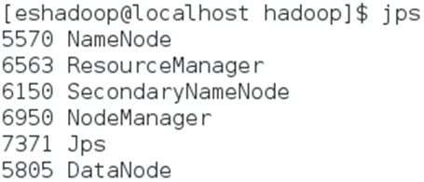

Figure 2‑10: Command to check the status of Daemons

### Elasticsearch Setup

Now, we download Elasticsearch, extract it to /usr/local, rename it and set eshadoop user as the owner of this directory:

$ sudo wget <https://download.elastic.co/elasticsearch/elasticsearch/elasticsearch-1.7.1.tar.gz>

$ sudo tar -xvzf elasticsearch-1.7.1.tar.gz -C /usr/local

$ sudo mv /usr/local/elasticsearch-1.7.1 /usr/local/elasticsearch

$ sudo chown -R eshadoop:hadoop /usr/local/elasticsearch

In the Elasticsearch folder we have a configuration file, elasticsearch.yml. This file is to be configured as per our requirements which is shown:

$ cd /usr/local/elasticsearch

$ sudo vi config/elasticsearch.yml

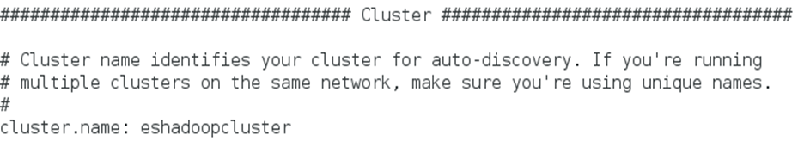

Figure ‑: Cluster Name in elasticsearch.yml File

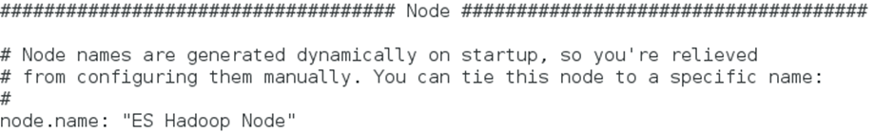

Figure ‑: Node Name in elasticsearch.yml File

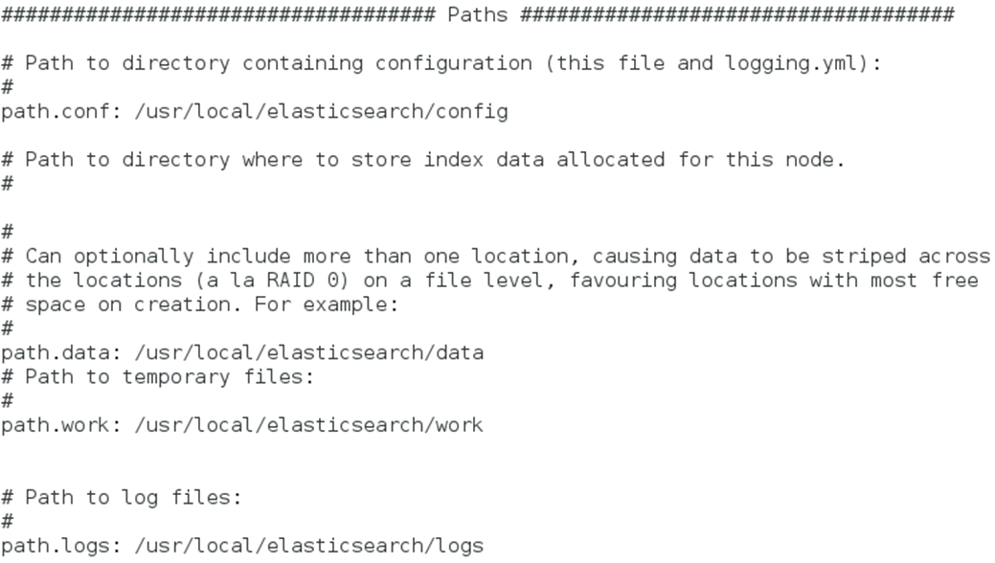

Figure ‑: Updating Paths in elasticsearch.yml File

Additionally, we installed Elasticsearch plugins Head and Marvel. Plugins are used to enrich the basic functionality of Elasticsearch in a custom manner.

* **Head plugin:**

$ sudo bin/plugin -install mobz/elasticsearch-head

It can be accessed at http://localhost:9200/_plugin/head/

* **Marvel Plugin:**

$ sudo bin/plugin -i elasticsearch/marvel/latest

Now, we run Elasticserach to see if it is successfully configured.



Figure ‑: Starting Elasticsearch

### Testing and Results

We took a sample data and run the Wordcount on it by building the Job Jar file. To do that we need certain prerequisites like JDK, Maven (which is a tool used for JAVA projects, as we use MapReduce jobs this tool is required), HDFS, YARN and Elasticsearch should be up and running. The data that we took is sample.txt which looks like:

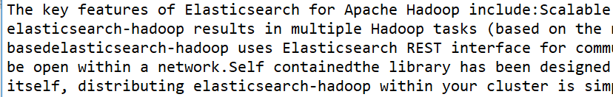

Figure ‑: Snippet of sample.txt File

In the same directory where we have this sample data we have the Mapper and Reducer classes which are used to split the input data, process it in parallel and produce the required output. The snippets of Mapper and Reducer classes are shown as follows:

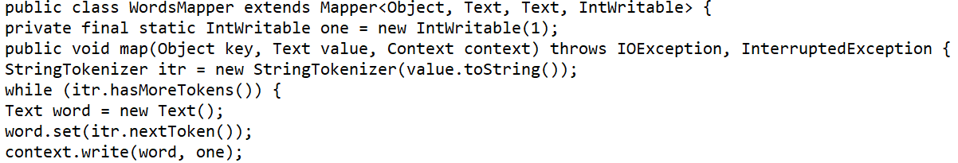

Figure ‑: Snippet of Mapper Class

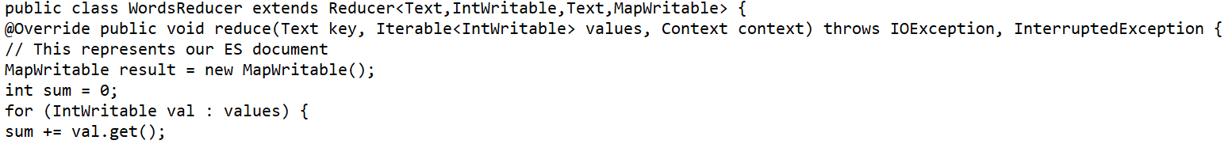

Figure ‑: Snippet of Reducer Class

To produce the Job Jar file, switch to the directory which contains the sample data and the code. Then run maven command:

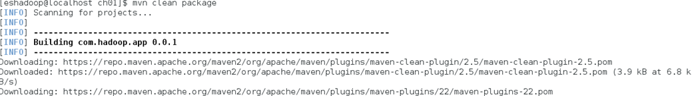

Figure ‑: Running Maven Command

Now a target directory with the Job Jar file is generated. We then import the sample file to HDFS by creating a directory and verify it after import is done.

$ hadoop fs -put sample.txt /input/ch01/sample.txt



Figure ‑: sample.txt File in HDFS

We then run the Jar file on the sample data which is in HDFS. This executes the Hadoop MapReduce job and imports the data to Elasticsearch. The Mapper class counts each word and

the Reducer class sums all these counts for each word. The output shows the log details that indicate the advancement in job execution.



Figure ‑: Running sample.txt File

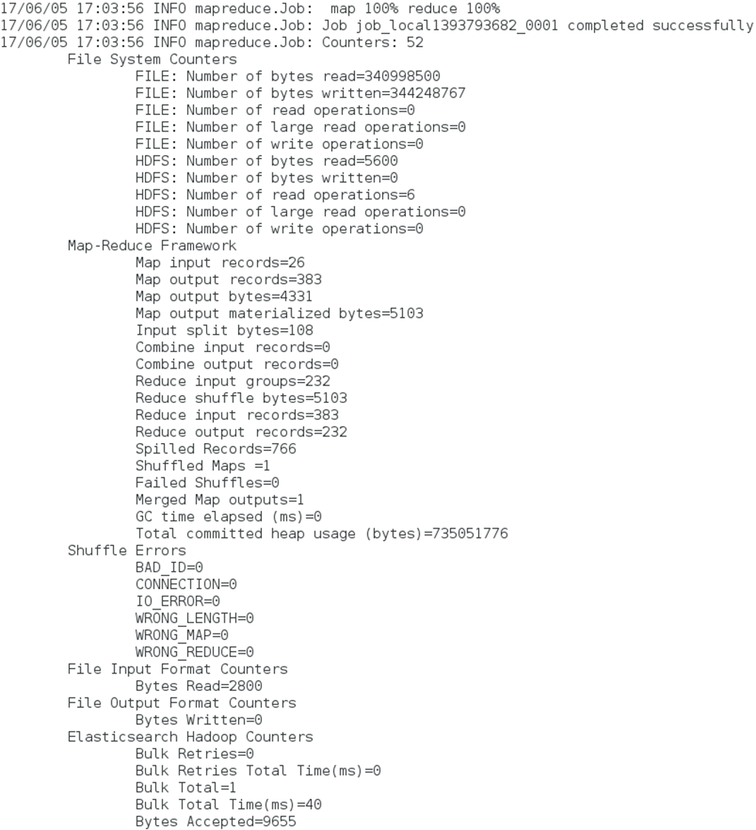

Figure ‑: Output of sample.txt File

### Data in Head and Marvel

Elasticsearch Head home page can be accessed through <http://localhost:9200/_plugin/head>.

Figure ‑: Home Page of Head Plugin

In the Head plugin we can see the eshadoop index for the WordCount program that we ran. This exactly matches with the number of documents metric that MapReduce job had produced as output. These details on Head can be seen on the Browser tab. Marvel is used as a monitoring interface for real-time analysis, it is a visualization tool for ES-Hadoop which is built on top of Kibana. Marvel can be accessed using <http://localhost:9200/_plugin/marvel/>.

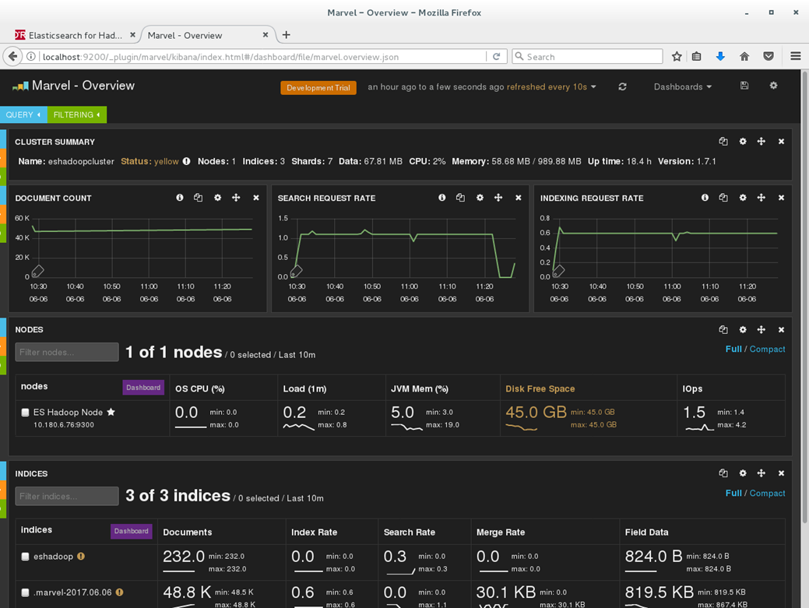

Figure ‑: Marvel Dashboard

Marvel provides a plugin named Sense which is a REST API client for ES-Hadoop server. It delivers auto suggestions which relieves us from memorizing ES-Hadoop query syntaxes. The Sense UI can be accessed through <http://localhost:9200/_plugin/marvel/sense/index.html>. When we write a search query in the Sense interface on the left-hand side, it displays the results on the right-hand side. This is very easy to work on and see the output on the same page.

In the below Sense screen, a search query is used to match all the documents indexed in eshadoop.

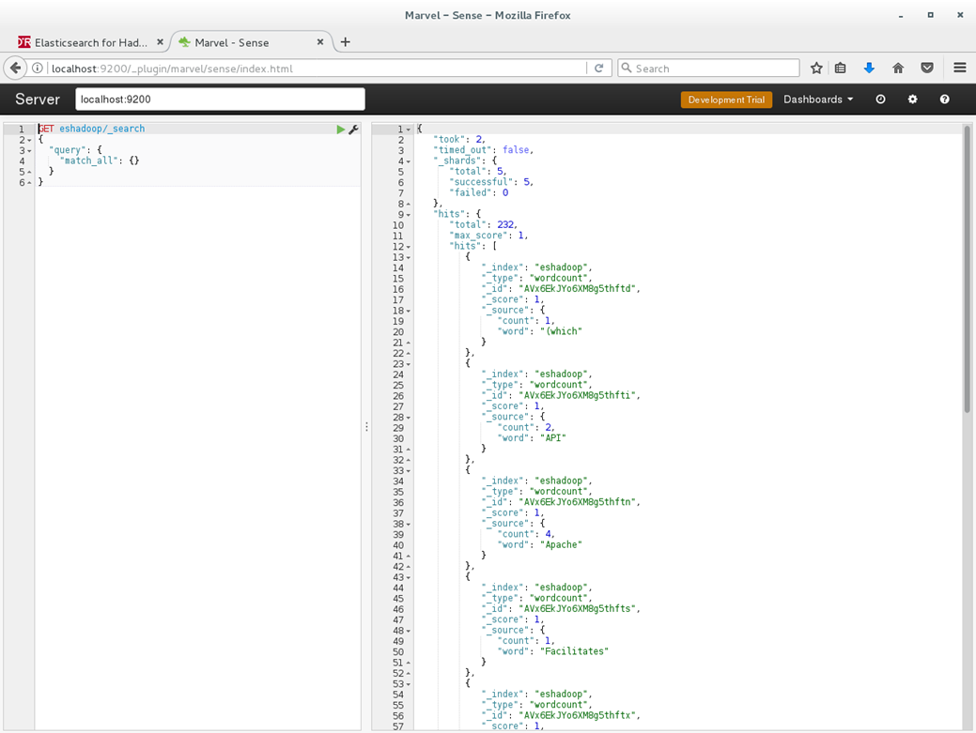

Figure ‑: Marvel-Sense Dashboard

Now we have the environment set up and operational to use Elasticsearch on Hadoop, to import data into HDFS by using MapReduce classes, and retrieve the data into Elasticsearch.

## Getting Started with ES-Hadoop

Hadoop provides a distributed batch-oriented storage and Elasticsearch provides a full-text search engine with rich aggregation abilities. Here we get started with ES-Hadoop to get data from Elasticsearch to Hadoop. Twitter dataset is used to run and test the processing capabilities of ES-Hadoop.

### Pushing Data from Elasticsearch to HDFS

First, we should get the data into Elasticsearch. Twitter dataset is the data that is being sent. Once we have the data and the source code, generate the Job Jar file and run it to put the data in Elasticsearch. We have concentrated only on #elasticsearch and #kibana hashtags, the Twitter dataset is placed as a CSV file and it looks like:

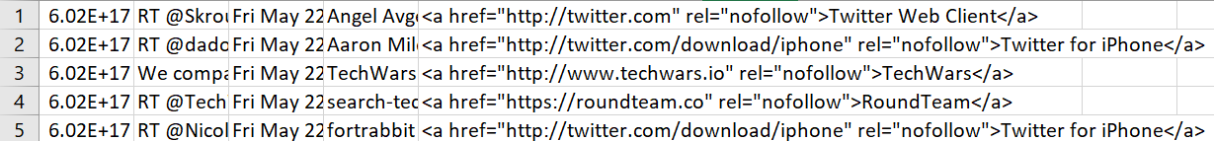

Figure ‑: Twitter Dataset

As we are initially sending the data to Elasticsearch, we used a Tweets2ESMapper class as source code:

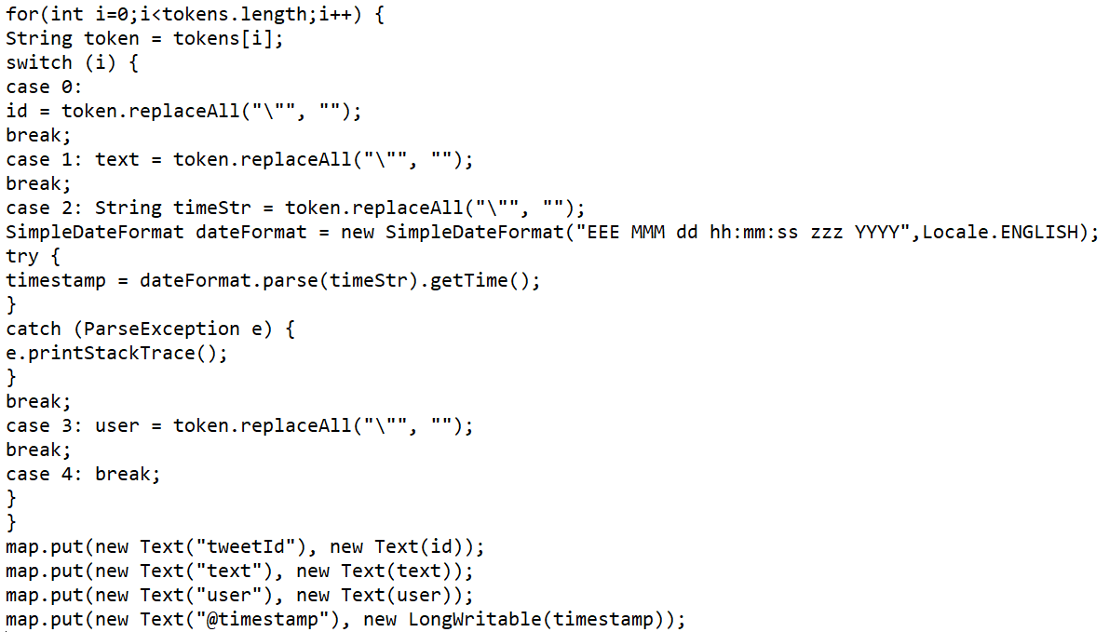

Figure ‑: Tweets2ESMapper Class Snippet

Now, we generated the Jar file and run it to get the data into Elasticsearch.



Figure ‑: Running tweets2es Jar File

The data is now pushed from Elasticsearch to HDFS by generating one more jar file, using the same dataset and a Tweets2hdfsMapper class.

The code snippet looks like:

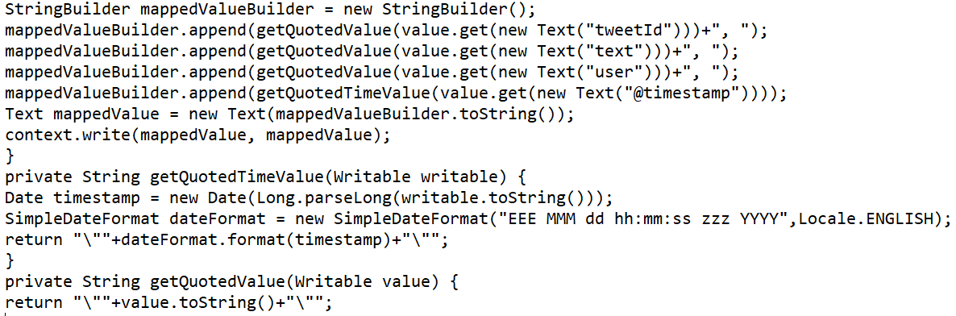

Figure ‑: Tweets2hdfsMapper Class Snippet

The Jar file is run to import the data to HDFS and the results are presented below:



Figure ‑: Running tweets2hdfs Jar File

Figure ‑: Results of Twitter Data

### Testing and results

Testing is performed to check if the job successfully produces a CSV file for the presumed tweet data. We use the below command to test the process:

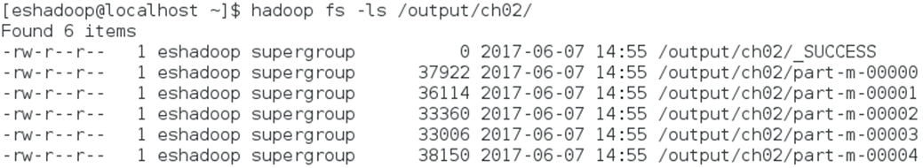

Figure ‑: Tweets data in HDFS

The content of the file is verified with the following command:

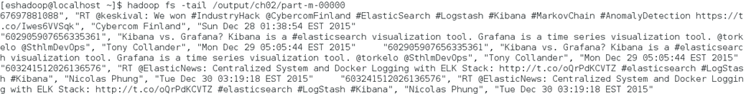

Figure ‑: Verifying the Tweet Content

Now we have pushed the data that is imported to Elasticsearch into HDFS and verified it.

## Elasticsearch and Kibana

Now we are ready to use Elasticsearch and its querying capabilities. We will use the CRUD operations with Elasticsearch to perform searches and aggregations. Working with Elasticsearch is easy when it comes to searching and analytics. We can start Elasticsearch with a single command and start indexing the document and perform search operations.

### CRUD

Elasticsearch offers a REST API to perform the CRUD operations. CRUD stands for Create, Retrieve, Update and Delete. To search a document in Elasticsearch we need to execute queries. To execute queries, we either need cURL or Sense interface. We have already seen how to work on Sense so here cURL is used. To use cURL, check if it is installed on the server.

$ curl –version

* **Create:** An index is created in Elasticsearch using the below query:

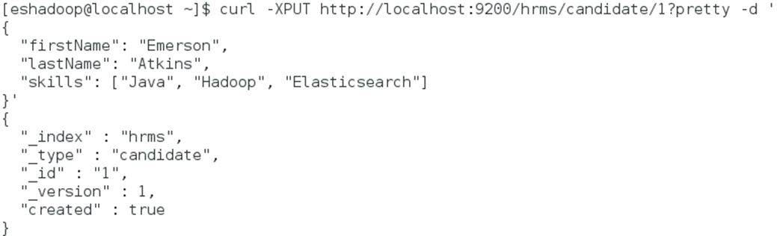

Figure ‑: Creating Index in Elasticsearch

* **Retrieve:** To retrieve the document that we indexed, the following query is used:

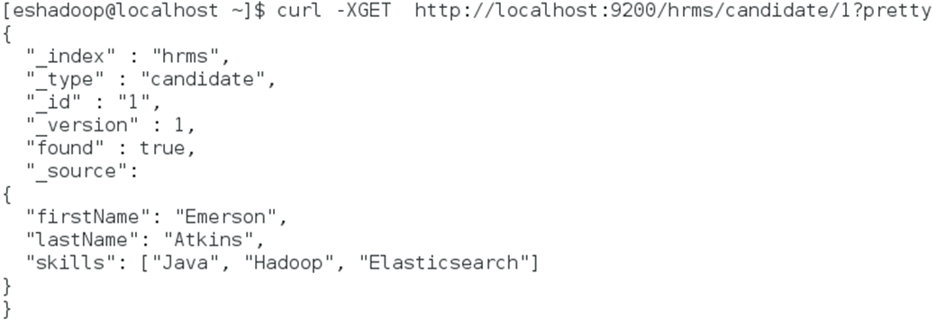

Figure ‑: Retrieving Data from Elasticsearch Index

* **Update:** If we want to make any changes to the existing document then:

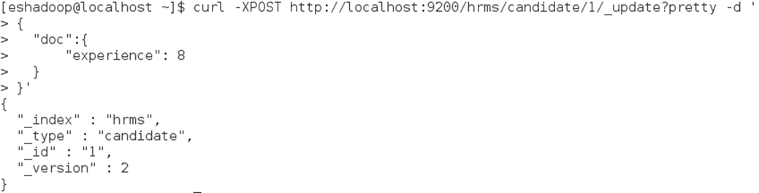

Figure ‑: Updating Elasticsearch Document

* **Delete:** Any document in Elasticsearch can be deleted using the delete query:

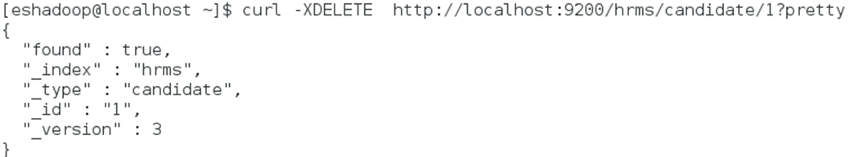

Figure ‑: Deleting Data from Elasticsearch Index

Mappings can also be created for Elasticsearch documents while indexing it.

$ curl -XGET <http://localhost:9200/hrms/candidate/_mapping?pretty>

The output is:

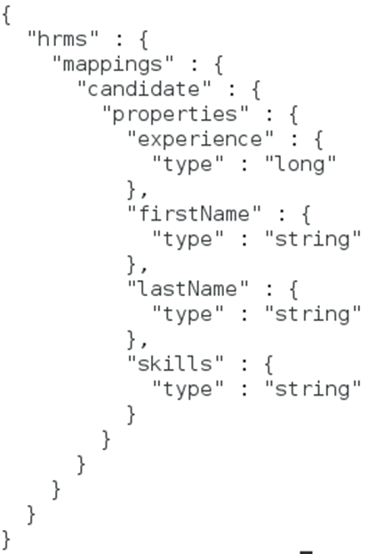

Figure ‑: Output of Mappings

Various search queries are supported by Elasticsearch which include URI search, match_all, term, Boolean, match, range, wildcard, etc. We can use these search queries based on the search request. All these queries are intended to perform some pertinent searches. When a document is given with a search query, we would want to know by the search results that if it is a match and how closely it matches. Filters are used to return only the documents that match the query. Different filter types supported by Elasticsearch are exists, geo distance, etc.

Aggregations module is one more important aspect in Elasticsearch. It is used to retrieve analytic information from a huge indexed dataset. Aggregations are equivalent to the GROUP BY clause and aggregate functions in relational database. When aggregations are executed on the indexed data, every cluster node executes aggregations locally and the result obtained from each node is collected and aggregated to get the final aggregated outcome. Commonly used aggregations in Elasticsearch are terms, histograms, range, geo distance, etc.

### Kibana Setup and Visualizations

Kibana is an interactive visualization tool which represents the data in different shapes, colors and sizes. We can investigate the data, visualize, slice and dice it with Kibana features when doing this process manually is a tedious task. To start with, install Kibana at /opt, extract and move it to a directory.

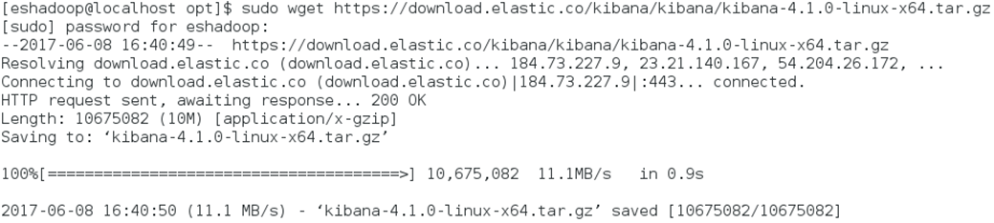

Figure ‑: Kibana Installation

$ sudo tar -xvf kibana-4.1.0-linux-x64.tar.gz

$ sudo mv kibana-4.1.0-linux-x64 kibana

The Kibana configuration file is updated as below:

$ sudo vi /opt/kibana/config/kibana.yml

port: 5601

host: “localhost”

elasticsearch_url: “http://localhost:9200”

We took a consumer_complaints data of csv format and Mapper source code.

The dataset snippets look as follows:



Figure ‑: Snippet of Consumer Complaints Data

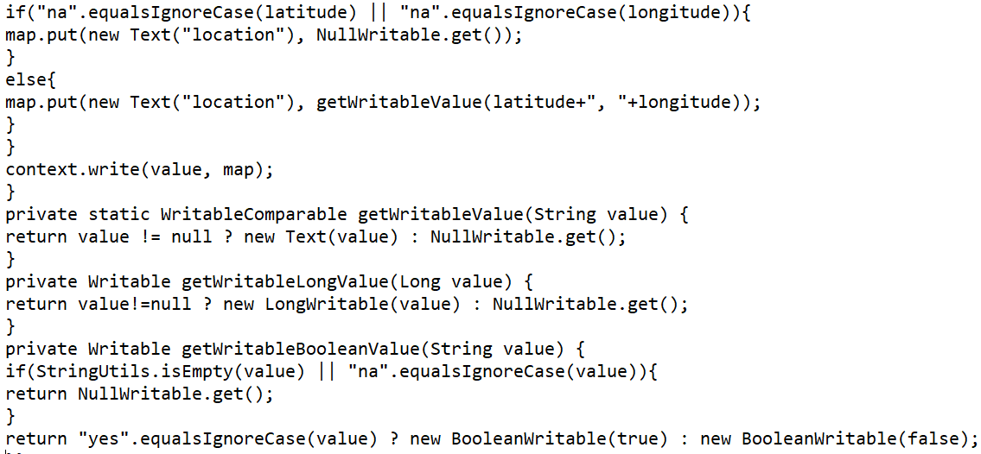

Figure ‑: Mapper Class Snippet

Now generate a Jar file and run it. It gives the below results.



Figure ‑: Running the Complaints Jar File

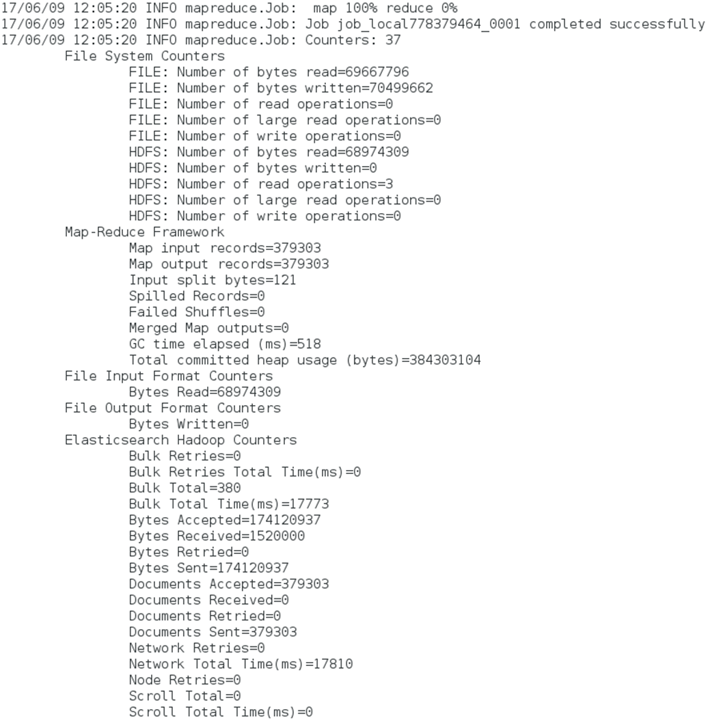

Figure ‑: Output of the Jar File

This data can now be visualized through Kibana. Kibana is started with the following command:

$ cd /opt/kibana/bin/kibana

Kibana is accessed from <http://localhost:5601/>.

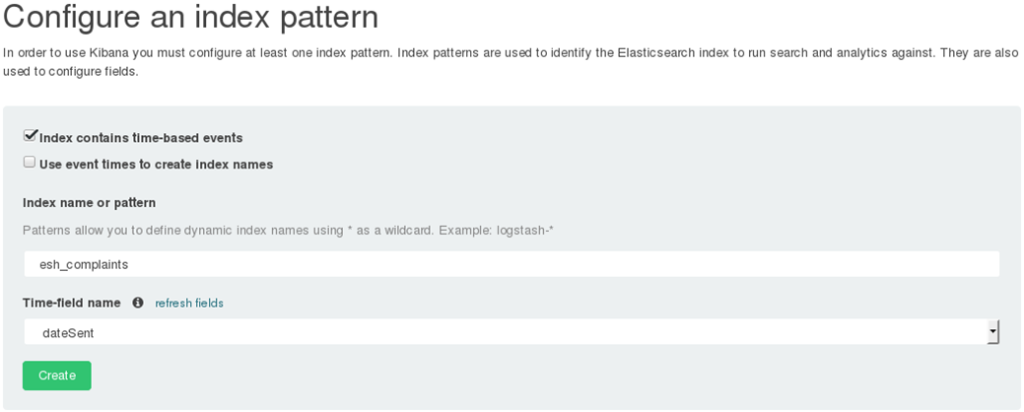

Figure ‑: Kibana Interface

After creating the index pattern, on the discover tab we could see the complaints in the form of visualizations.

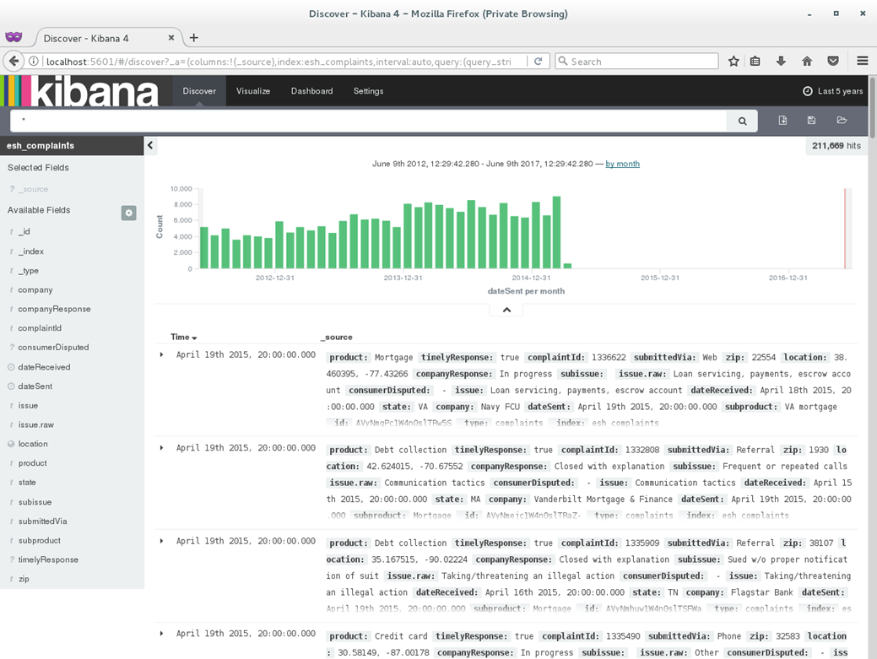

Figure ‑: Visualization of the Consumer Data

To create a new visualization, go to visualize tab, select pie chart.

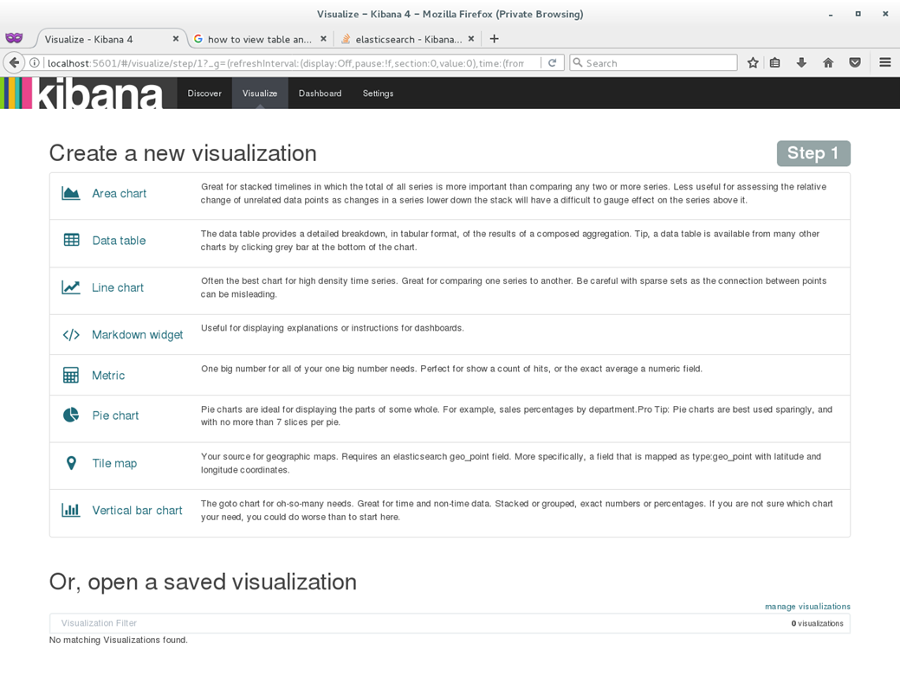

Figure ‑: Visualization Options on Kibana

From the left side, we can set the metrics as we want and the result looks as below for the metrics that we selected.

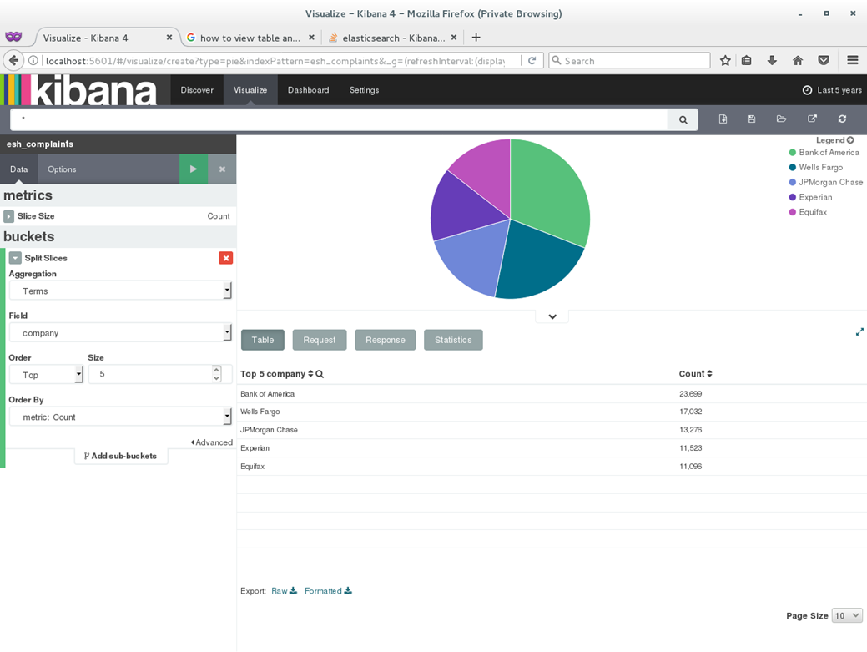

Figure ‑: Visualization of Consumer Complaints on Kibana Pie Chart

Similarly, it can be visualized in multiple views. We implemented the below visualizations:

* **Stacked bar chart**

Figure ‑: Stacked Bar Chart Visualization of Consumer Complaints

* **Histogram**

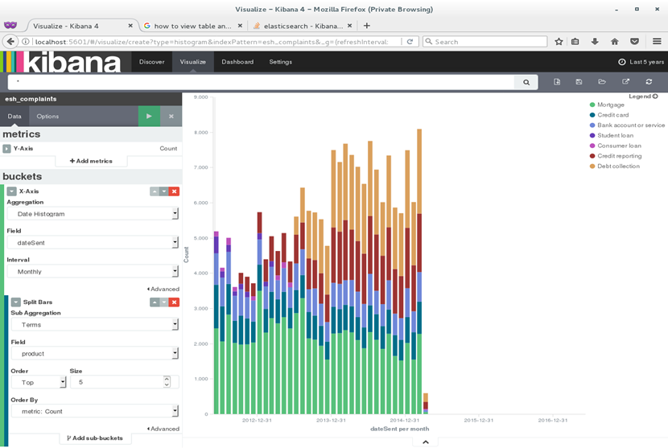

Figure ‑: Histogram Visualization of Consumer Complaints

* **Area chart**

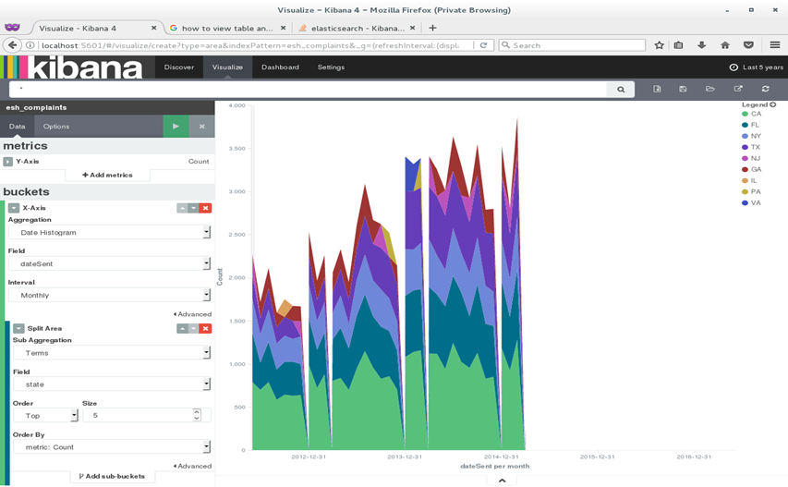

Figure ‑: Area Chart Visualization of Consumer Complaints

* **Split pie chart**

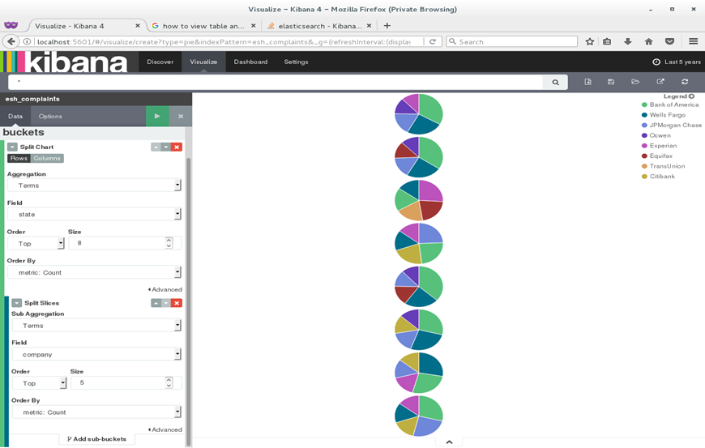

Figure ‑: Split Pie Chart Visualization of Consumer Complaints

* **Sun burst chart**

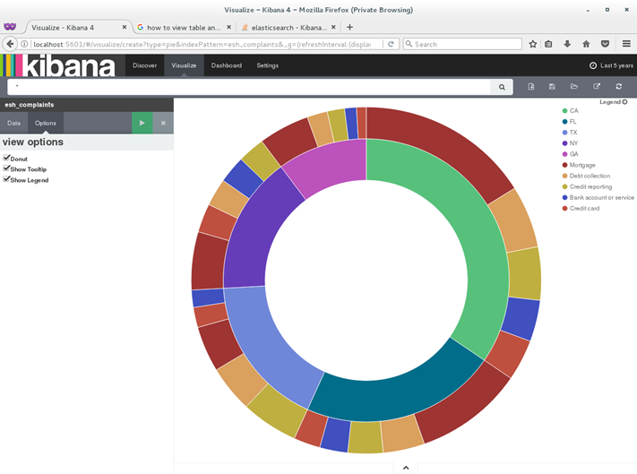

Figure ‑: Sun Burst Chart Visualization of Consumer Complaints

* **Geographical chart**



Figure ‑: Geographical Chart Visualization of Consumer Complaints

This is how Elasticsearch indexing works and Kibana visualizations are shown with many different options and implementations.

## 

We perform Real-Time Analytics on Twitter Trend Analyzer by importing the real-time streaming data into Elasticsearch using Apache Storm.

### Apache Storm

Apache Storm is downloaded, extracted and moved to a directory in /usr/local location.

$ sudo wget <http://www.apache.mesi.com.ar/storm/apache-storm-0.9.5/apache-storm-0.9.5.tar.gz>

$ sudo tar -zxvf apache-storm-0.9.5.tar.gz

$ sudo mv apache-storm-0.9.5 storm

The .bashrc is updated with the storm binary path by adding the below line:

$ export PATH=$PATH:/usr/local/storm/bin

Now Storm is ready and if we want to set up Storm for production environments then we should setup Zookeeper along with its daemons: Nimbus (acts as a master), Supervisor (acts as a slave) and UI (this is for Storm UI interface) to run the Storm topologies. Zookeeper provides a centralized service for retaining configuration details, synchronizations and many other services.

It is downloaded, extracted and moved to the respective directory using the below commands:

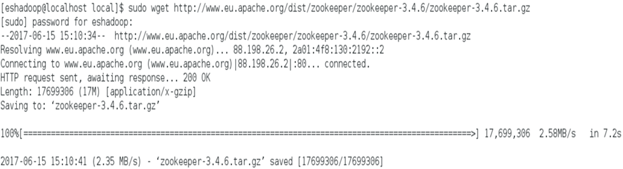

Figure ‑: Zookeeper Installation

$ sudo tar -zxvf zookeeper-3.4.6.tar.gz

$ sudo mv zookeeper-3.4.6 zookeeper

Zookeeper binaries are added to the .bashrc file as:

$ export PATH=$PATH:/usr/local/zookeeper/bin

The JAVA_HOME environment variable is set on the storm_env.ini file and permissions are set to Storm and Zookeeeper as eshadoop users in Hadoop group.

$ export JAVA_HOME=/usr/lib/jvm/java-1.8.0-openjdk-1.8.0.131-2.b11.el7_3.x86_64/jre

$ sudo chown -R eshadoop:Hadoop /usr/local/storm

$ sudo chown -R eshadoop:Hadoop /usr/local/zookeeper

Then the Storm configuration file is updated with the below changes:

$ sudo vi /usr/local/storm/conf/storm.yaml

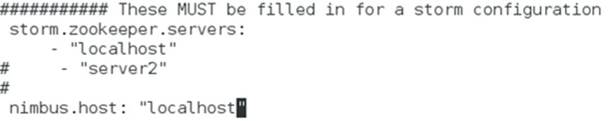

Figure ‑: Storm Configuration

Now, Zookeeper and its daemons are started:

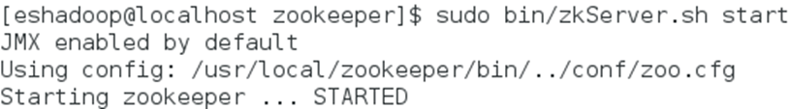

Figure ‑: Starting Zookeeper

* **Nimbus**

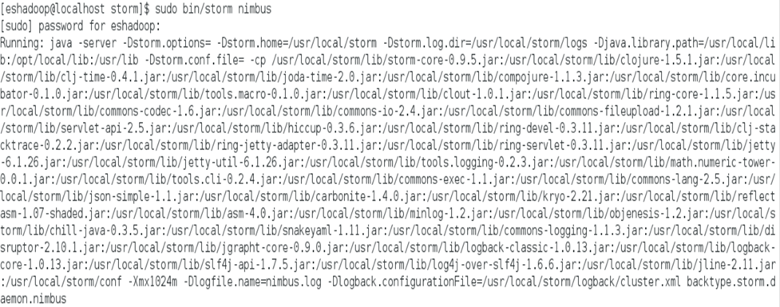

Figure ‑: Starting Nimbus

* **Supervisor**

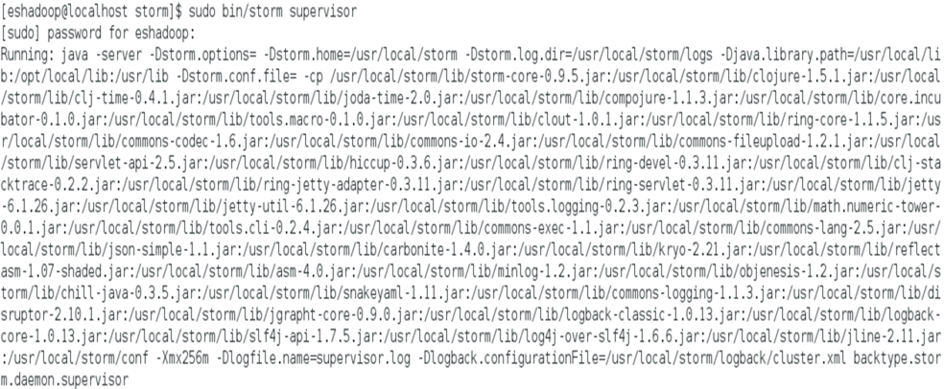

Figure ‑: Starting Supervisor

* **UI**

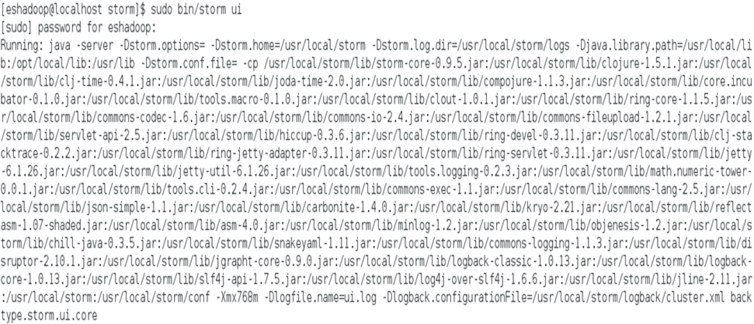

Figure ‑: Starting Storm UI

To check if all the daemons are running successfully, run the command:

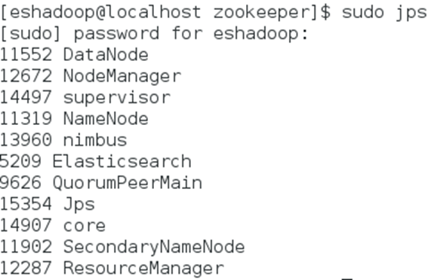

Figure ‑: Command to Check the Status of Daemons

The Storm UI can be accessed from localhost:8080

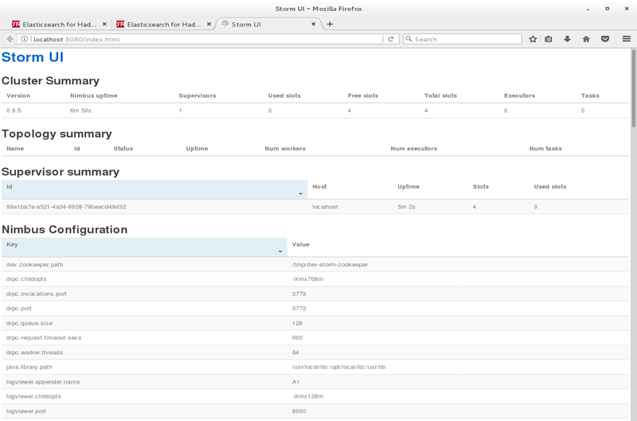

Figure ‑: Storm UI

Apache Storm uses Spouts and Bolts as a topology to collect and parse the twitter streams. Spout is a medium of streams in a topology. It collects tuples from multiple data sources and puts it in the topology. Bolts does all the processing in the topology like filter, aggregate, join, etc. Stream transformations are done by bolts.

The code snippet for Spout and Bolt looks as below:

* **TweetsCollectorSpout**

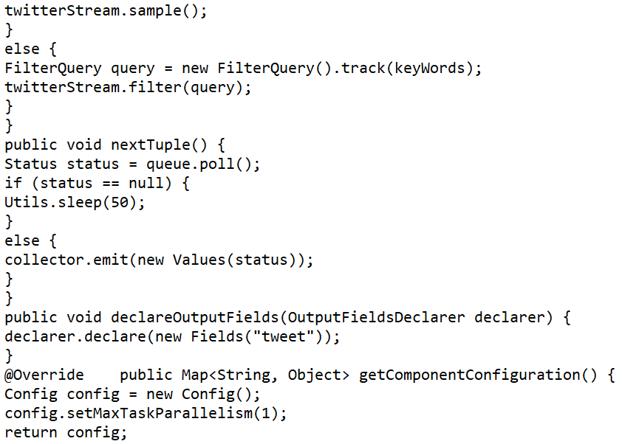

Figure ‑: Snippet of Spout

* **TweetsParserBolt**

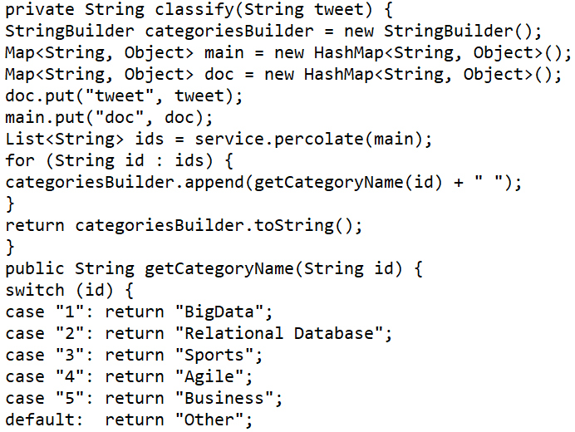

Figure ‑: Snippet of Bolt

### Twitter Trend Analyzer

To work with the Twitter Trend Analyzer, we first need to create a twitter application from the link <https://apps.twitter.com>.

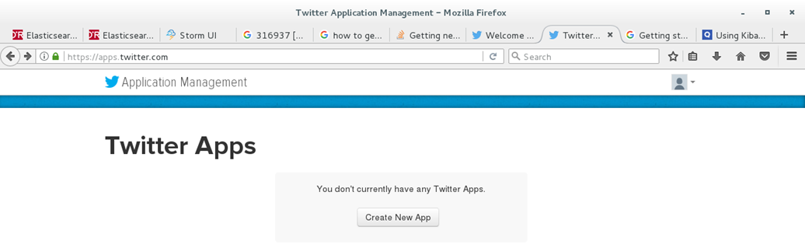

Figure ‑: Twitter App

Figure ‑: Creating Twitter Application

Upon completion of the application, on the Details tab → Application Settings → Access Level → click on modify app permissions and change it to read, write and access direct messages. Click on Keys and Access Tokens tab which gives the Consumer Key, Consumer Secret, Access Token and Access Token Secret keys. We should update these keys in the TweetsCollectorSpout code file. Then we generate a Job Jar file and run the Storm job with the following command which outputs the Tweets and the data is imported to Elasticsearch.

$ storm jar ch05-0.0.1-job.jar com.packetpub.esh.streaming.Topology

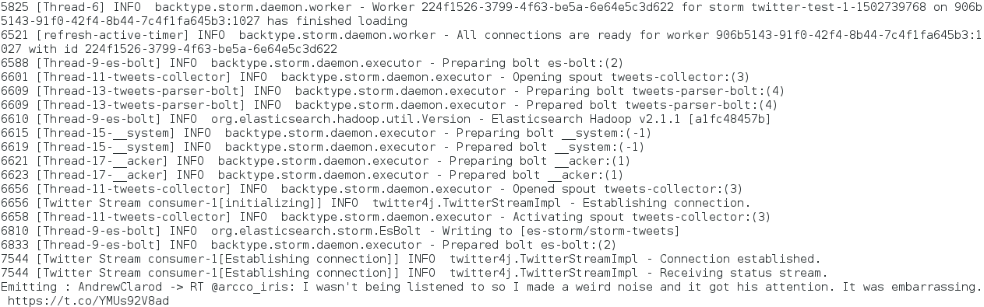

Figure ‑: Running the Storm Job

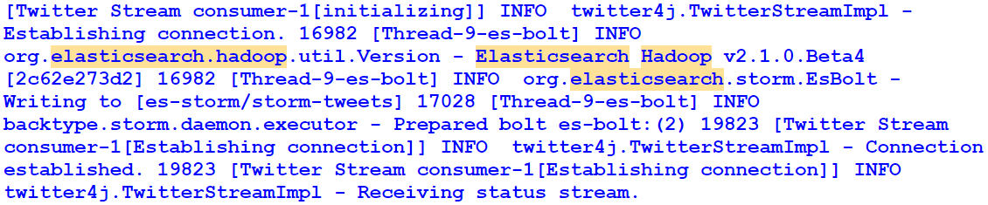

Figure ‑: Output of Twitter Streaming Data

### Kibana Visualizations

The results that we got from the Storm job are represented in Kibana by creating a bar chart and choosing the required aggregations. The interface looks like:

Figure ‑: Twitter Data on Kibana

This is how we experimented on the Twitter Trend Analyzer to stream real-time data and showcase it in Kibana.

## Hadoop Ecosystem

So far, we have seen how to push the data from Elasticsearch to HDFS and Vice Versa. Now we completely focus on the Hadoop ecosystem to experiment how ES-Hadoop integrates with the Hadoop tools. Hadoop ecosystem does an excellent job in making Hadoop easily understandable by various users and by providing multiple Hadoop environments for interfacing such as Pig, Hive, Spark, Cascading and so on.

### Pig with Elasticsearch

Pig is the simple and easiest way to play around with the data without any complicated programming. Pig uses a textual language known as Pig Latin. Pig is installed, extracted and moved to a directory by following the below commands:

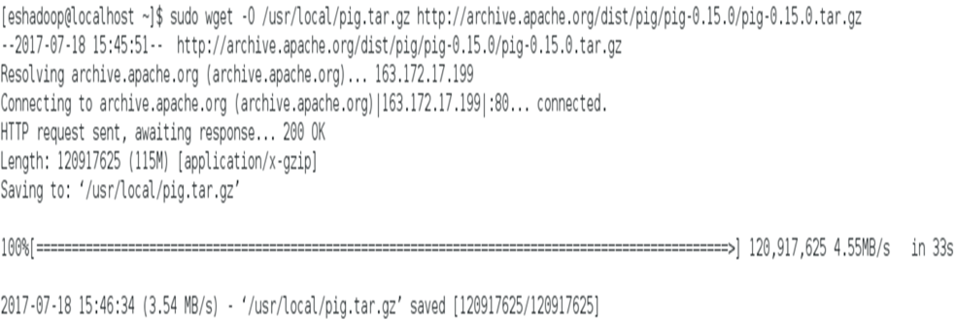

Figure ‑: Pig Installation

$ cd /usr/local

$ sudo tar vxzf pig.tar.gz

$ sudo mv pig-0.15.0 pig

Next the environment variables are configured in the .bashrc file.

$ export PIG_HOME=/usr/local/pig

$ export path=$PATH:$PIG_HOME/bin

To start the job daemon run the below command.

$ mr-jobhistory-daemon.sh start history server

Now, Pig is ready and we get into the Pig console called grunt using the command below:

$ pig



Figure ‑: Grunt Shell

We must ensure that the ES-Hadoop Jar file is in the Pig class path, to use Pig with Elasticsearch. So, we download the Jar file and import it to HDFS.

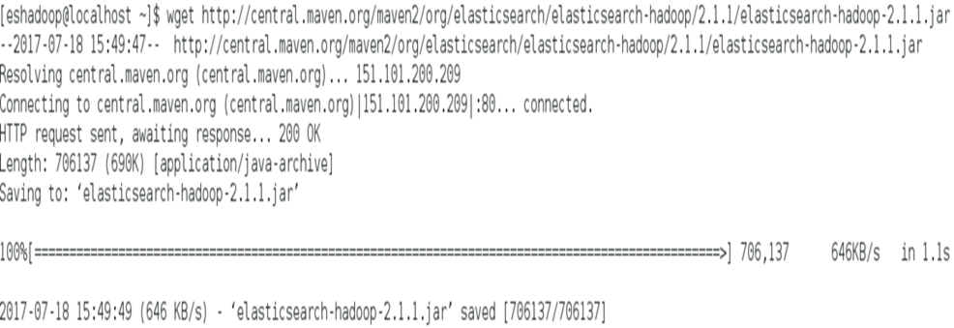

Figure ‑: Installing ES-Hadoop Jar File

Create a directory /opt/lib and move the Jar file to it.

$ sudo mkdir /opt/lib

$ sudo mv elasticsearch-hadoop-2.1.1.jar /opt/lib

Then we import the Jar to HDFS:

$ hadoop fs -mkdir /lib

$ hadoop fs -put opt/lib/elasticsearch-hadoop-2.1.1.jar /lib/elasticsearch-hadoop-2.1.1.jar

We take a sample dataset crime, generate a Jar file, run the file and import the data to HDFS:

$ hadoop fs -put crimes_dataset.csv /lib/crimes_dataset.csv

To import this data to Elasticsearch we use an EsStorage class that Pig Storage provides. This class needs to be registered with the ES-Hadoop Jar which is done as:

grunt> REGISTER hdfs://localhost:9000/lib/elasticsearch-hadoop-2.1.1.jar;

Now, we load the CSV data as a relation from grunt.

This command reads the complete data and maps each token with its respective field mentioned in the command.

**grunt> SOURCE = load '/ch07/crimes_dataset.csv' using PigStorage(',') as (id:chararray, caseNumber:chararray, date:datetime, block:chararray, iucr:chararray, primaryType:chararray, description:chararray, location:chararray, arrest:boolean, domestic:boolean, lat:double,lon:double);**

The target Pig relation is generated that matches the target Elasticsearch index closely.

**grunt> TARGET = foreach SOURCE generate id, caseNumber, date, block, iucr, primaryType, description, location, arrest, domestic, TOTUPLE(lon, lat) AS geoLocation;**

Finally, the target is loaded to Elasticsearch index.

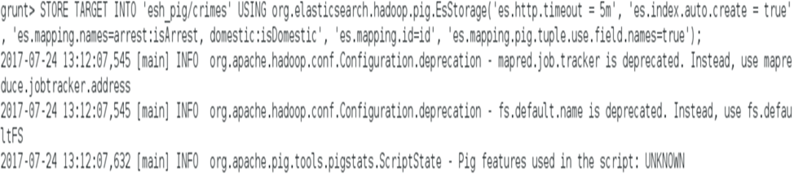

Figure ‑: Loading Crime Data to Elasticsearch Index

This command will give us the results about the crime data documents pushed into Elasticsearch.

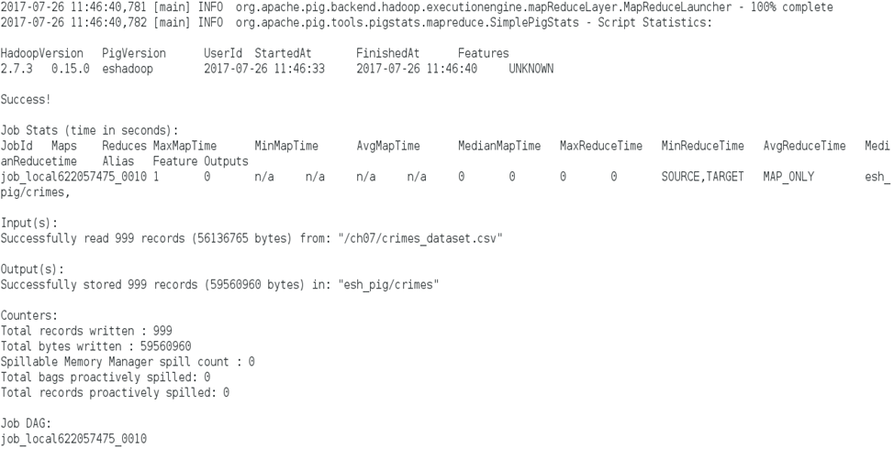

Figure ‑: Results of Crime Data

To read data from Elasticsearch through Pig, we can use the below queries:



Figure ‑: Reading Data from Elasticsearch

When we type the below command, it gives us the requested results.

grunt> dump ES;

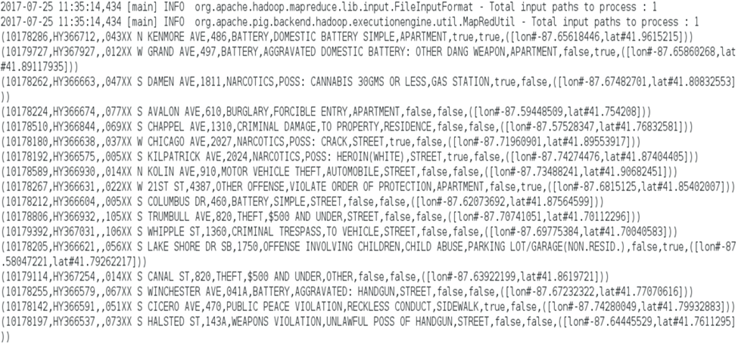

Figure ‑: Results in Elasticsearch

This is how data is imported into Elasticsearch and retrieved using Pig console.

### Elasticsearch with Hive using SQL

Hive provides a SQL interface to the data in Hadoop Ecosystem. Hive is a data warehouse that provides data summarization, query and analysis. To setup Hive, download, extract and move it to /usr/local.

Figure ‑: Hive Installation

**$ sudo tar –xvf hive.tar.gz**

**$ sudo mv apache-hive-1.2.1-bin hive**

Configure the environment variables in .bashrc file.

export HIVE_HOME=/usr/local/hive

export PATH=$PATH:$HIVE_HOME/bin

export CLASSPATH=$CLASSPATH:/usr/local/hive/lib/*:.

export HADOOP_USER_CLASSPATH_FIRST=true

export HIVE_AUX_JARS_PATH=/opt/lib/elasticsearch-hadoop-2.1.1.jar

Set the Hadoop path in hive-env.sh config file:

export HADOOP_HOME=/usr/local/Hadoop

When we type the command hive, it takes us to the hive console.

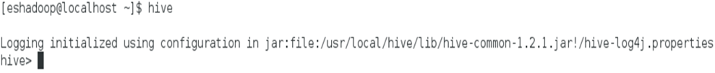

Figure ‑: Hive Console

Importing the data to Elasticsearch in Hive is initiated by creating an external table.

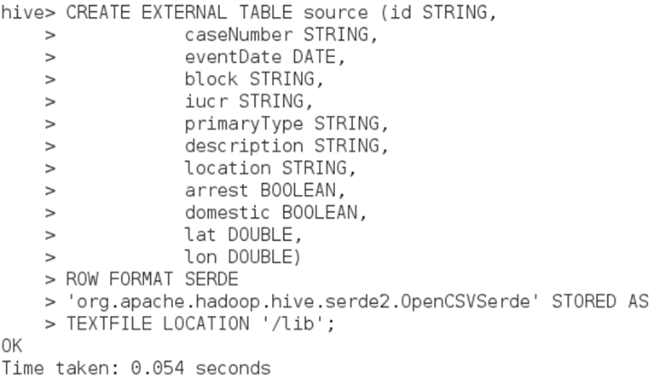

Figure ‑: Creating Table in Hive

Create a target table for crimes that points to Elasticsearch index.

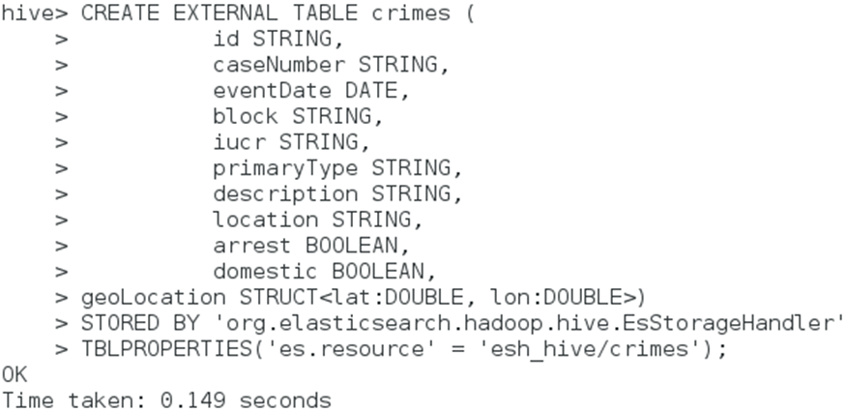

Figure ‑: Target Table

Now collect all the data from source table and insert into the crimes table using the below command:

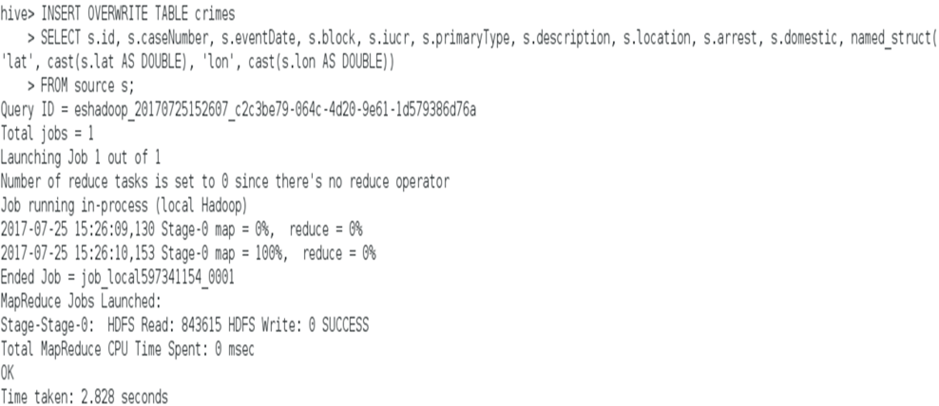

Figure ‑: Inserting Data into Crimes Table

Here, let’s see how to read the data from Elasticsearch. If we want to retrieve all theft crime documents, we first create a hive table:

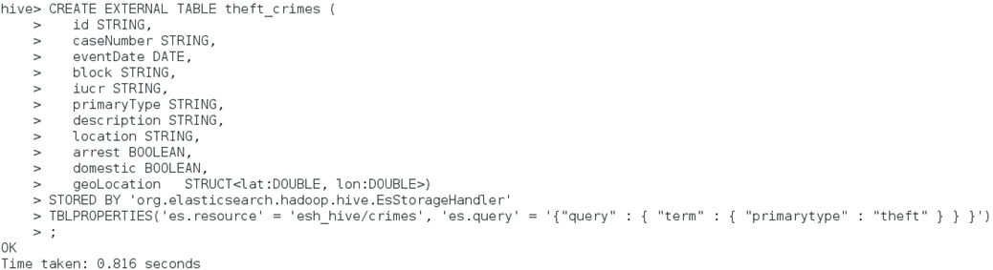

Figure ‑: Creating Hive Table for theft_crimes

We can write SQL queries to get the data from Elasticsearch.

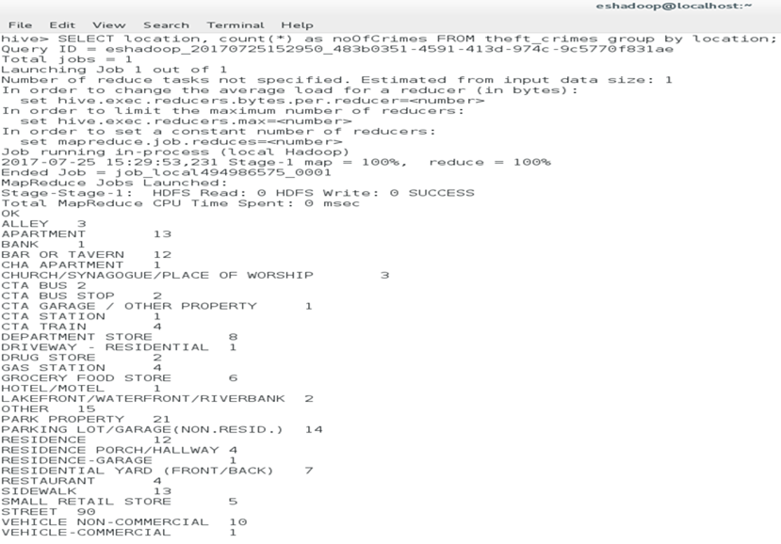

Figure ‑: Results from the Requested Query

In this way, Hive makes it possible to read the indexed data from Elasticsearch using SQL queries. In summary, with the Elasticsearch on Hadoop cluster, we have experimented, learned and tested how data can be imported to Elasticsearch, indexed, processed and visualized using different tools of Hadoop. We have also created a Twitter Trend Analyzer which streams real-time data using Elasticsearch Hadoop methodologies.

# ELASTICSEARCH USING AWS

In the previous section, we have completely worked on a local CentOS 7 workstation. In this section, we implemented Elasticsearch in AWS using its services.

The major difference in working on a local server and AWS is that, in the local machine we use Elasticsearch in conjunction with multiple tools separately and we need to start up each service every time we want to use Elasticsearch. And it is a very challenging job to run real time analytics on a local system as a user. If we have the data already then, we want the analysis to be simple and easy.

AWS provides all the built-in tools that are required for data analysis. It provides an interface where streaming, analytics, Elasticsearch and Kibana can be accessed. AWS supplies a cloud environment with data storage buckets and services to stream real-time data. We could write code in any programming language to stream the data to AWS and perform analytics and visualizations on the streamed data. AWS provides a powerful, comprehensive, and easy-to-use infrastructure for streaming and analyzing real-time data.

## AWS Account

First, we need to have an AWS account to start with. Account creation can be done from this link: <http://aws.amazon.com/>.

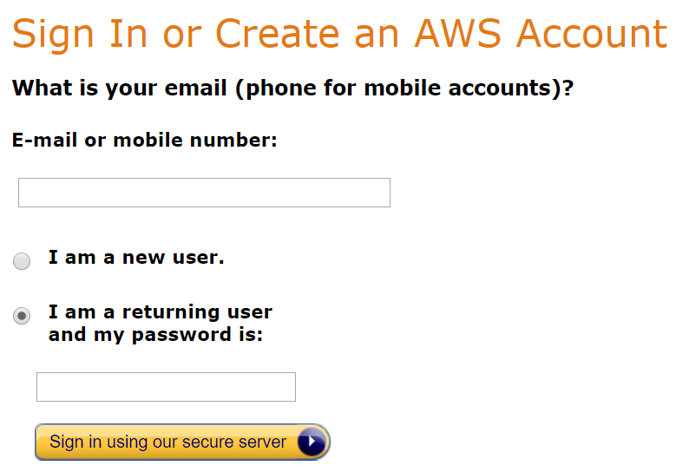

Figure ‑: Creating AWS Account

## Architecture

The architecture that we used to build this process is shown and explained as below:

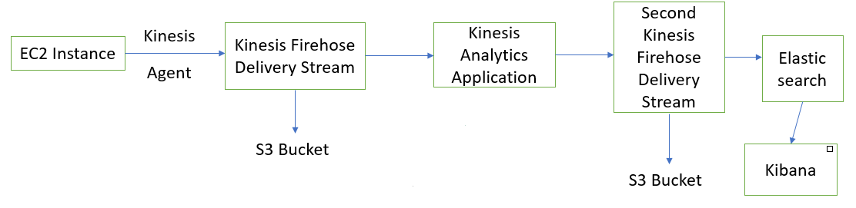

Figure ‑: Data Analytics Architecture in AWS

## EC2 Instance

EC2 stands for Elastic Compute Cloud. It is a simple web service provided by Amazon which acts like a virtual cloud in AWS. EC2 allows us to configure an environment that we have complete control of. We created an EC2 instance with all the required settings:

Sign in to the AWS console. We used a Linux instance. Before starting the instance we created an IAM user, key pair and a security group. To create the IAM user, login to the console at <https://console.aws.amazon.com/iam/>. Select Users and choose Add user. Update the settings and click on Next: Permissions.

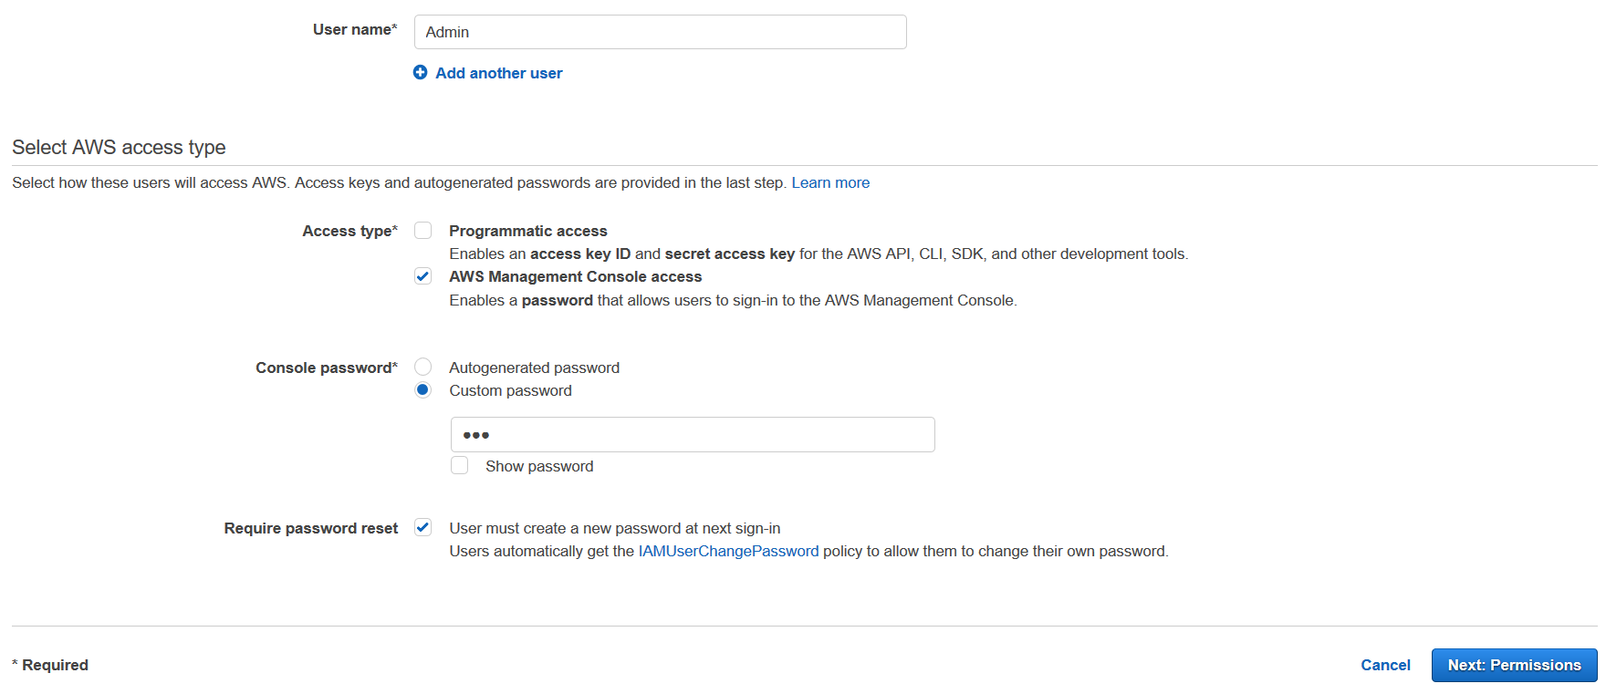

Figure ‑: Creating IAM User

Choose Create group, set the configurations and click on Create group.

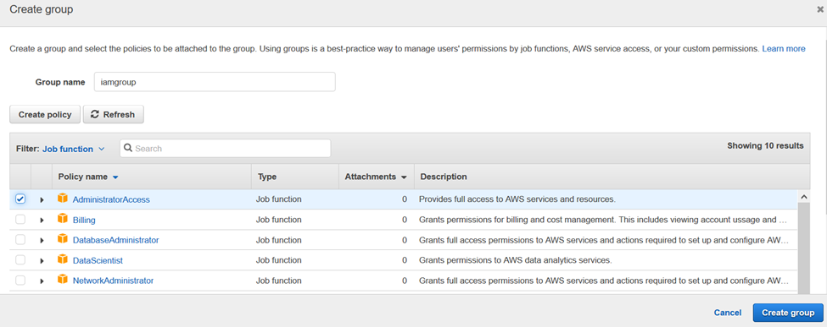

Figure ‑: Creating IAM Group

Click on Next: Review and Create user. Then open EC2 console to create a key pair. From the top right choose the region, we selected Virginia. From the left side select key pairs under network & security.

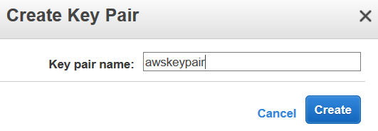

Figure ‑: Creating Key Pair

A private key automatically appears and we should save the file.

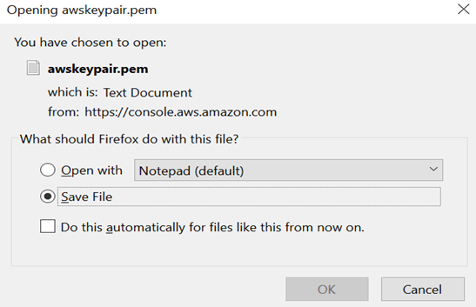

Figure ‑: Private Key Pem File

We use PuTTY to connect to AWS instances. Open PuTTYgen, choose RSA and click on Load. Select all files and open the awskeypair.pem. Now click on Save private key and save it as awskeypair. Choose Security groups from the EC2 console, click on Create security group.

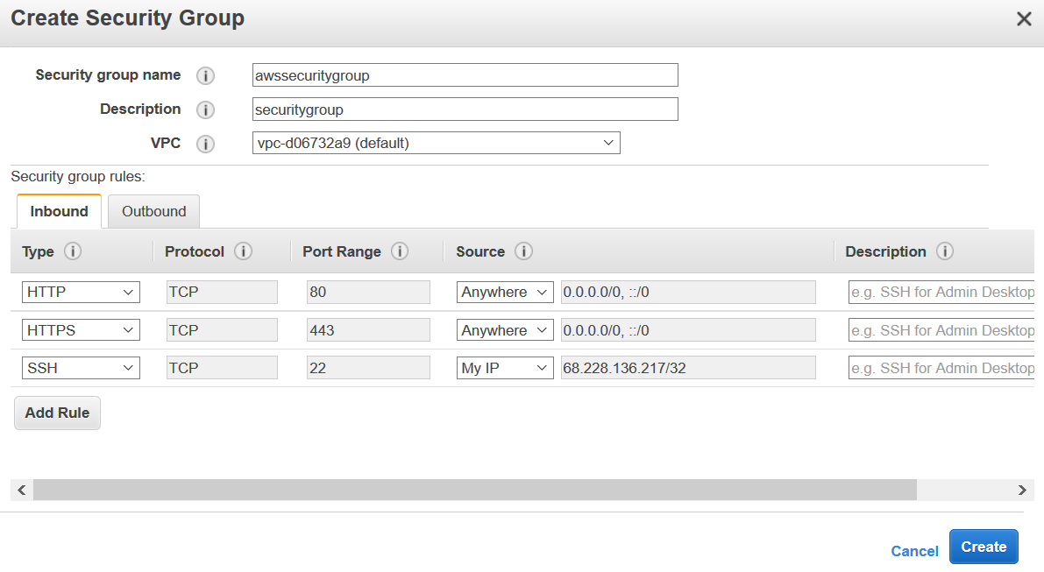

Figure ‑: Creating Security Group

Before launching the instance, create an IAM role from the IAM console, click on Roles and Create new role. For Role type select Amazon EC2. On the Attach the policy page, select AWS managed, and on the Role name and review page set the configurations:

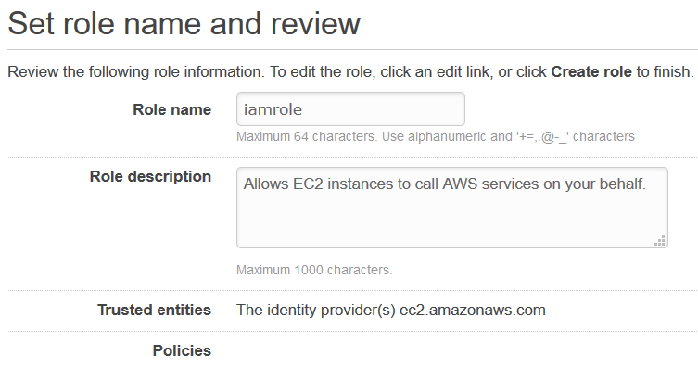

Figure ‑: Creating IAM Role

Now go back to Instance creation, open EC2 and launch instance.

Choose Linux AMI, t2.micro type. Proceed to the next page and select the security group that was previously created. Click on launch. Choose the key pair that we created earlier.

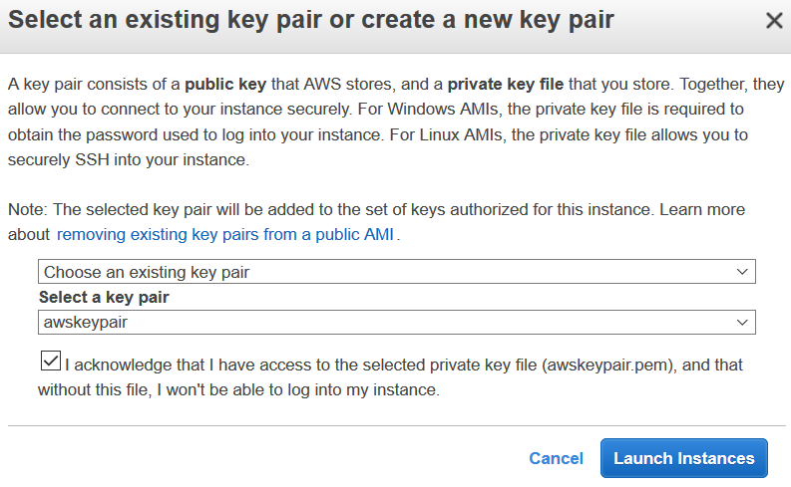

Figure ‑: Choosing the Key Pair

After the instance is successfully launched, we connected to it using PuTTY. Update the configurations on PuTTY and connect to it.

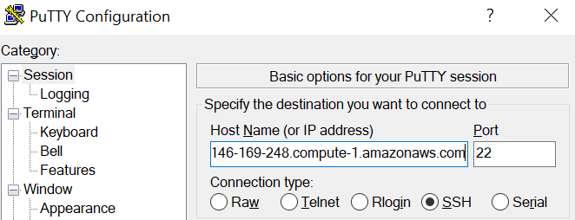

Figure ‑: PuTTY Configuration: Session

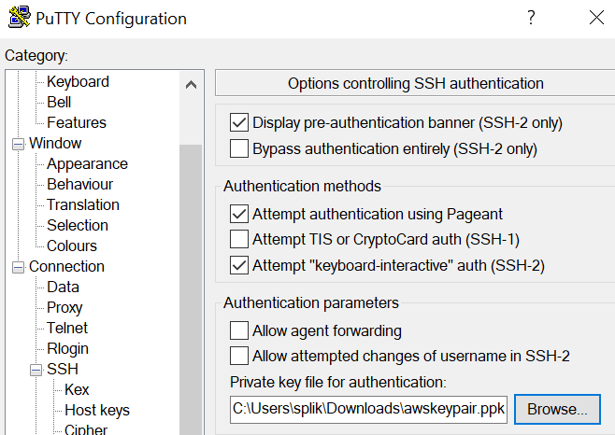

Figure ‑: PuTTY Configuration: Authentication

Now we are successfully connected to the EC2 instance through PuTTY.

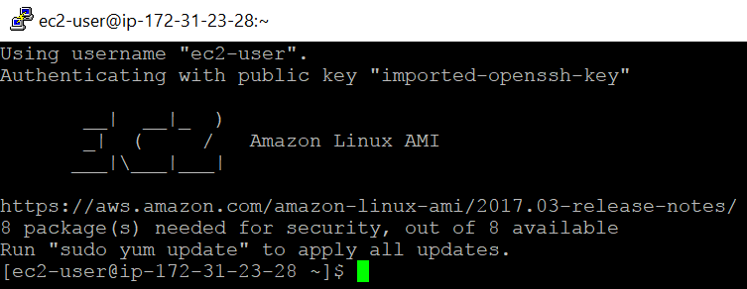

Figure ‑: EC2 Console

## Log Files

We used a Python program to stream the Apache Access logs. This Python code sends continuous logs to the Kinesis Stream. A snippet of the code is shown below:

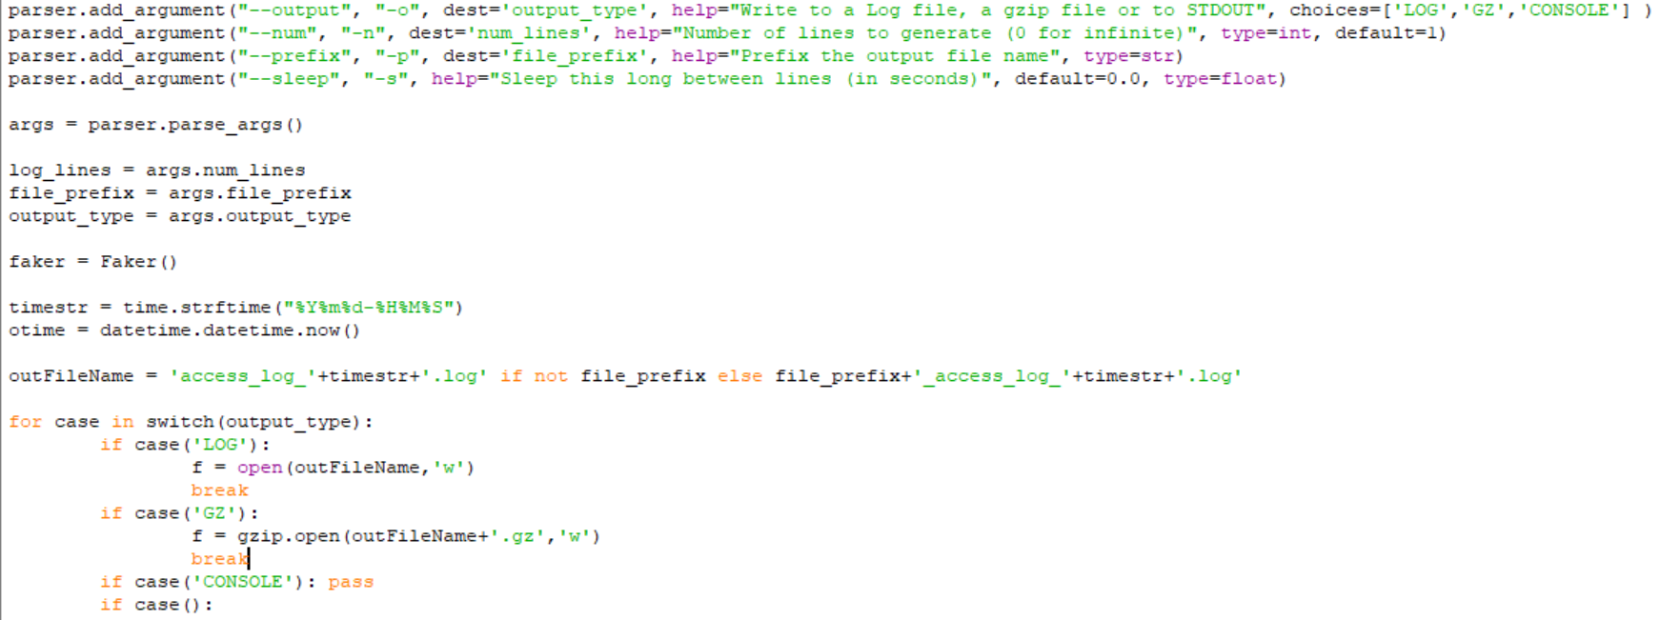

Figure ‑: Python Code Snippet for Apache Access Logs

This Python code is run to generate log stream. The command used is:



Figure ‑: Command to Run the Python Code

## Kinesis Firehose Delivery Stream

Kinesis Firehose is a managed service used to transmit real-time streaming data to Elasticsearch. Before the logs are analyzed by Amazon Kinesis Analytics, we first loaded them to AWS using Kinesis Firehose. It saves each log entry in Amazon Simple Storage Service (S3). S3 is a storage bucket that can manage very large datasets. Kinesis Firehose Delivery Stream can be created from the console on AWS.

Open the Kinesis page and go to the Firehose console. Create the delivery stream.

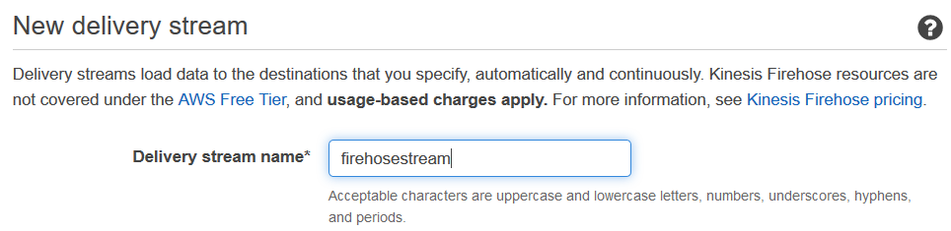

Figure ‑: Creating Kinesis Firehose Delivery Stream



Figure ‑: Creating S3 Bucket

After configuring click on Create delivery stream. The stream is successfully created.

## Kinesis Agent

Amazon Kinesis Agent is a stand-alone application that collects and sends data files to Kinesis Firehose. An Agent continuously tracks the logs and sends new data to the stream. In this scenario, Agent is used to send logs from EC2 to Kinesis.

The Agent is downloaded and installed using the following command:

$ sudo yum install -y aws-kinesis-agent

Next we edit the agent.json file located at /etc/aws-kinesis.

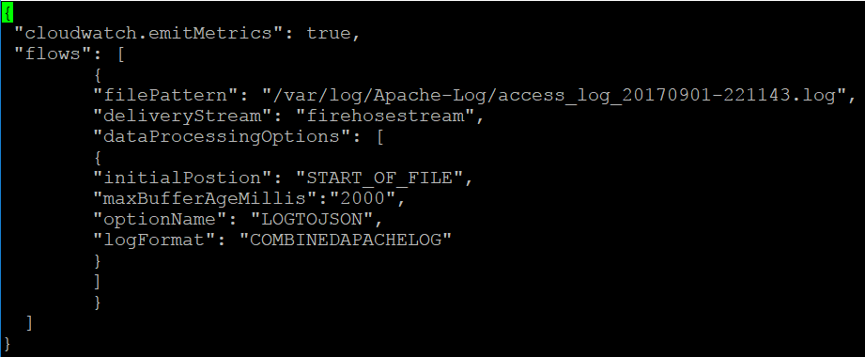

Figure ‑: agent.json File

The aws-kinesis-agent is restarted after updating the agent.json file.



Figure ‑: Restarting aws-kinesis-agent

Now we can see the logs saved in S3 bucket and can monitor them from the Kinesis Firehose.

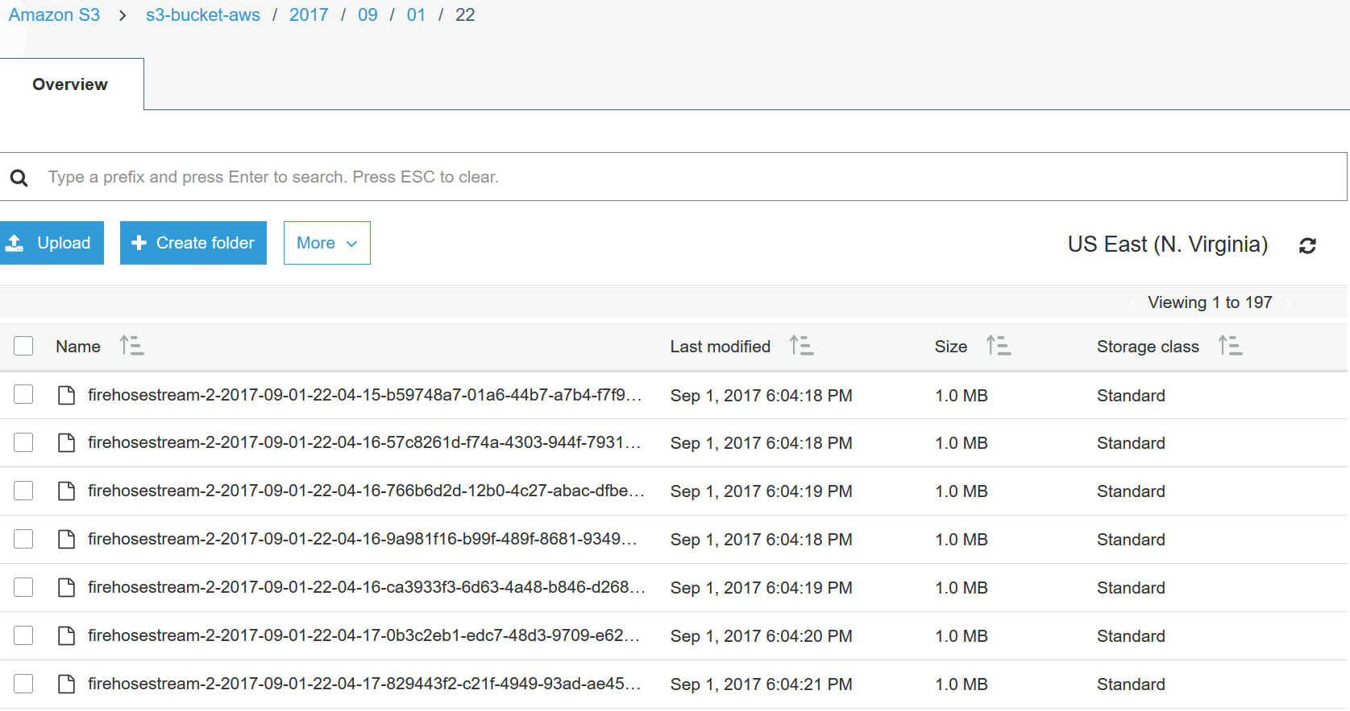

Figure ‑: Logs in S3 Bucket

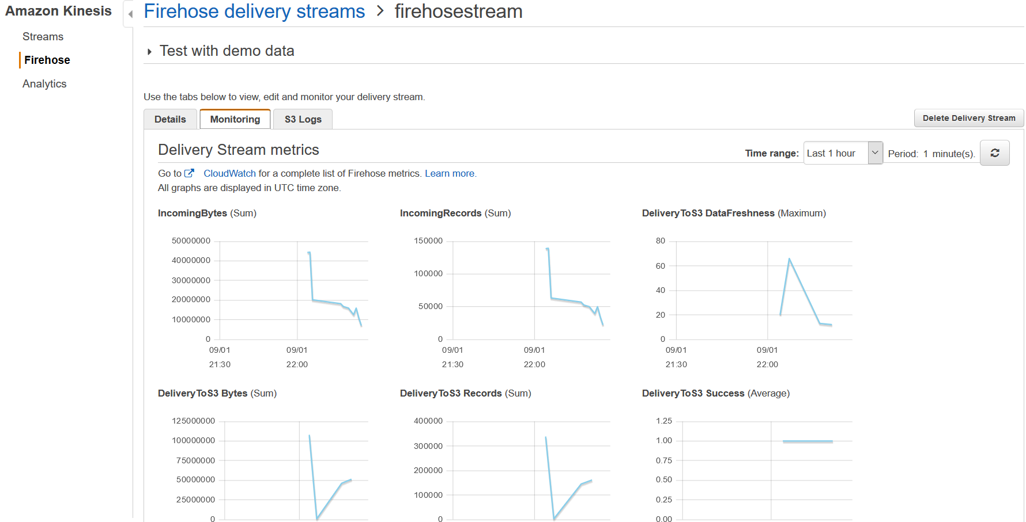

Figure ‑: Data Monitoring from Firehose

## ES Domain

We created an Elasticsearch domain to store the produced data and use it for analysis and visualizations. To create the domain, go to Elasticsearch Service on AWS. Click on Create new domain and update the configurations.

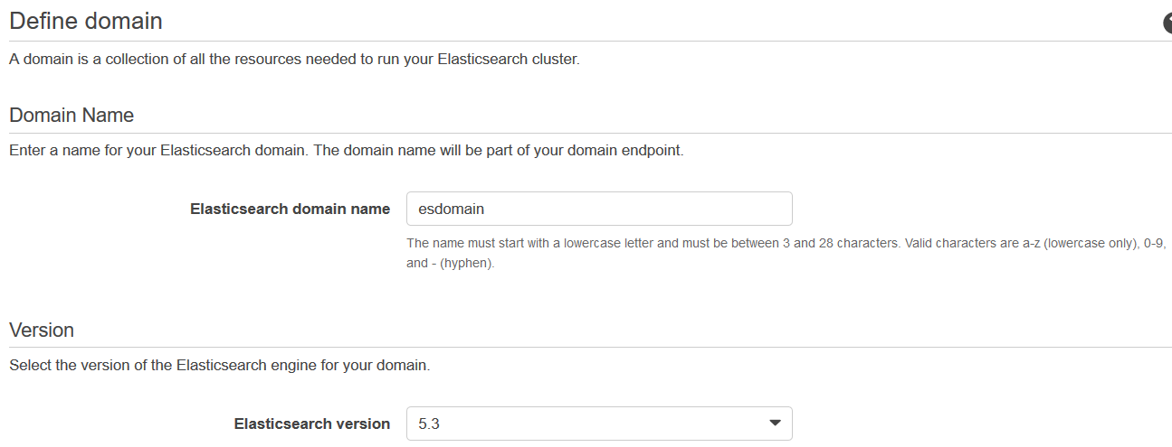

Figure ‑: Creating Elasticsearch Domain

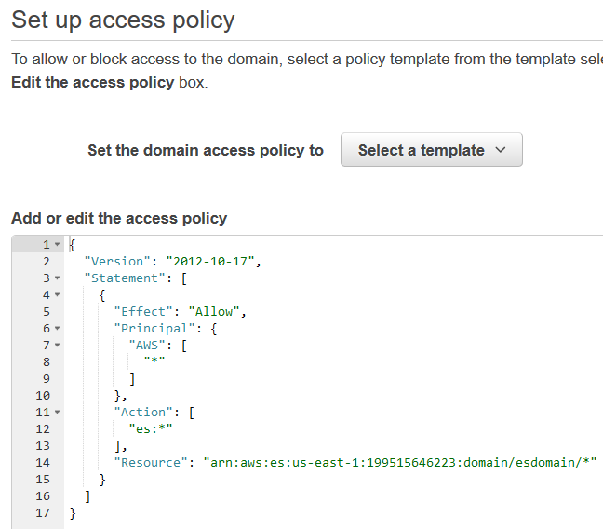

Figure ‑: Setting Up Access Policy

The ES Domain is successfully created.

## Second Kinesis Firehose Delivery Stream

We created a second Kinesis Firehose Delivery Stream to store the output produced by the Kinesis Analytics Application. So, the data from the first Firehose will be sent to the Analytics, and after processing and analyzing the data, it is sent to ES with the help of the second Kinesis Firehose Stream.

We created one more S3 bucket to store the data that is being aggregated. Create it by opening the Kinesis console and select on Firehose. Click on Create delivery stream and complete the settings.

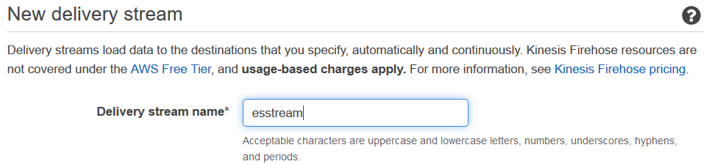

Figure ‑: Creating Second Kinesis Firehose Delivery Stream

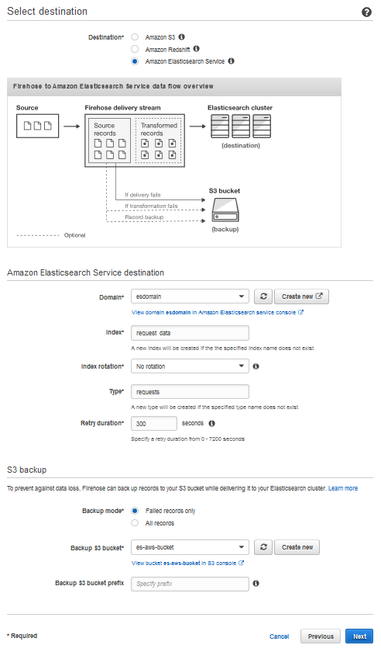

Figure ‑: Creating Destination and S3 for Second Delivery Stream

On the configuration page, change the settings:

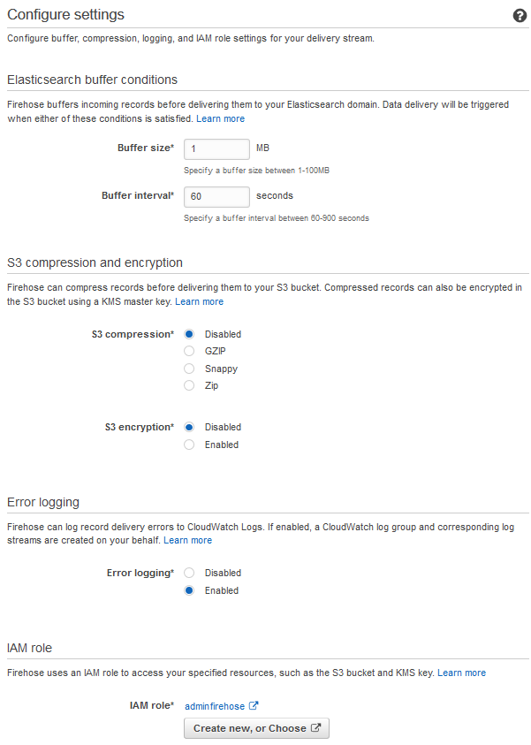

Figure ‑: Configuration Settings

The second Kinesis Firehose Delivery Stream is now created.

## Kinesis Analytics Application

The next processing step is the Kinesis Analytics Application, which aggregates data from the streaming logs and stores it to ES domain using the second Firehose. On the Kinesis console, click on Analytics and create a new application.



Figure ‑: Creating Kinesis Analytics Application

Click on connect to a source and select the first Firehose stream.

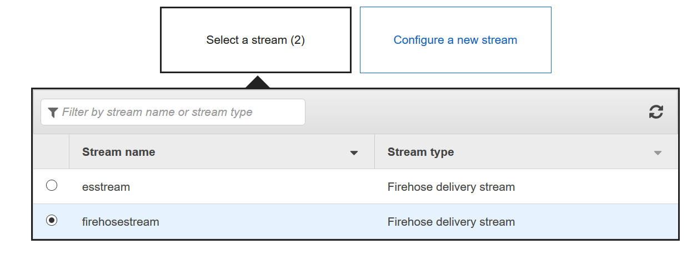

Figure ‑: Connecting to a Source

Kinesis Analytics shows us the streaming data.

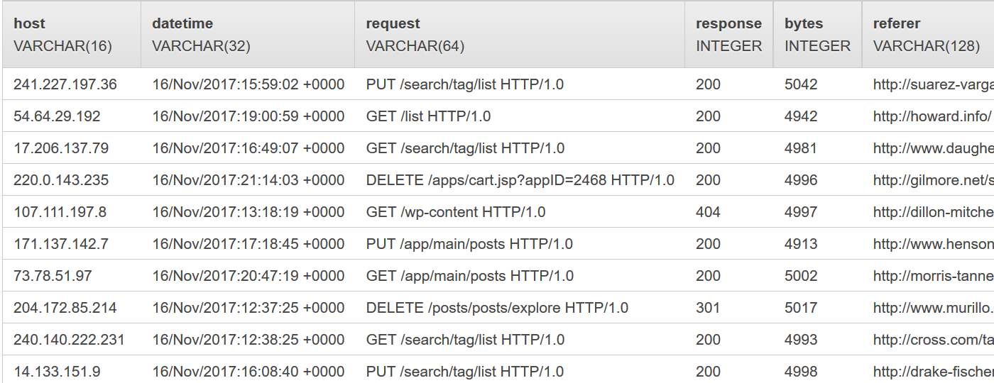

Figure ‑: Streaming Data from Kinesis Analytics

Go back to the Analytics page and go to SQL editor and start the application.Onthe SQL editor page, we passed a SQL code on the Analytics and we will see the real-time analytics provided by Kinesis Analytics Application.

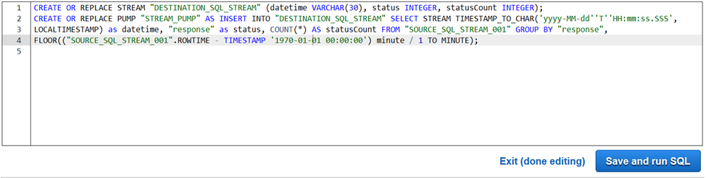

Figure ‑: SQL Command to Generate Real-Time Logs

We could see the real-time log analytics which is the result of this entireprocess.

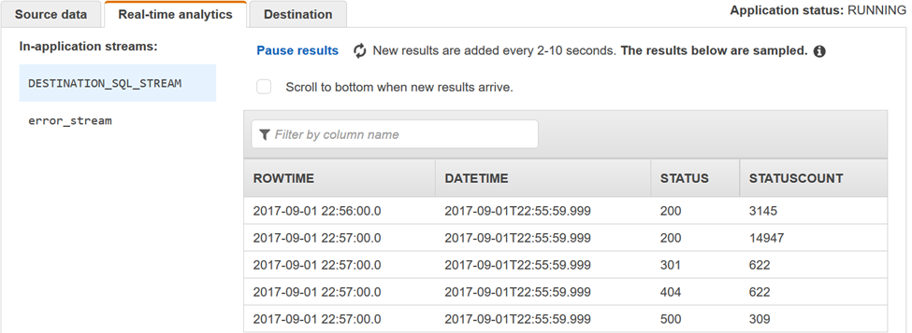

Figure 3‑30: Real-Time Analytics

To save this streaming output to a destination, click on the Destination tab and select the second Firehose stream which was created.

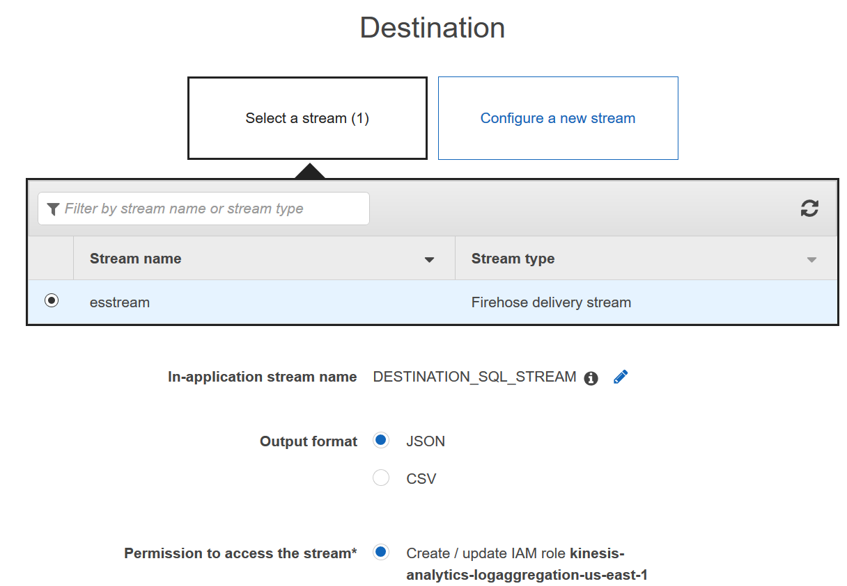

Figure ‑: Storing Streaming Data to Second Firehose Destination Stream

After a few minutes, the output from SQL command will be stored to the ES domain.

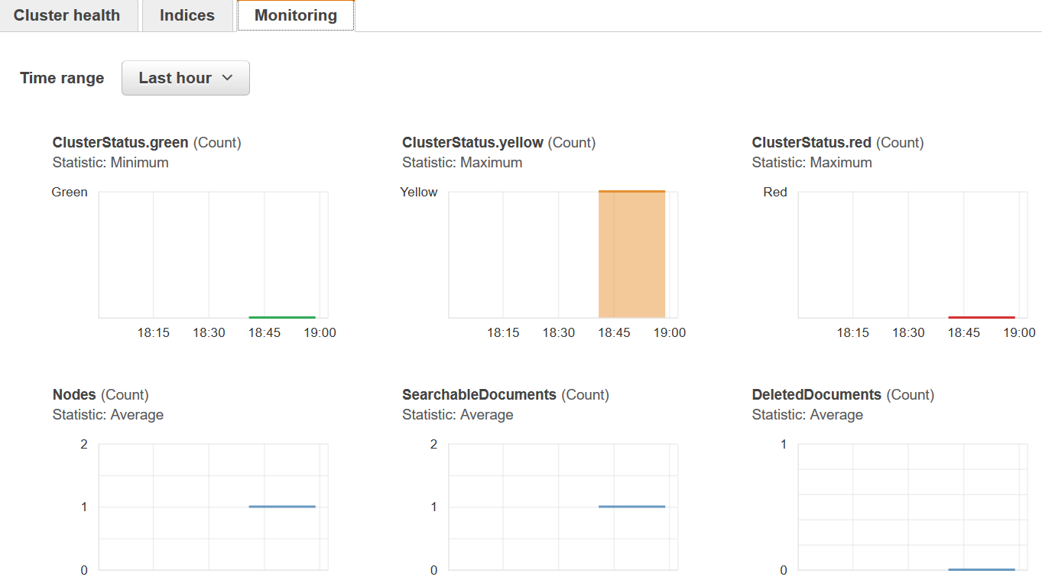

Figure ‑: Monitoring Real-Time Data from Elasticsearch Service Domain

## Kibana

To visualize the logs that are streaming in real-time, we used an Elasticsearch’s User Interface, Kibana. Open Elasticsearch Service and open the ES domain. Here we could see a link to access Kibana.

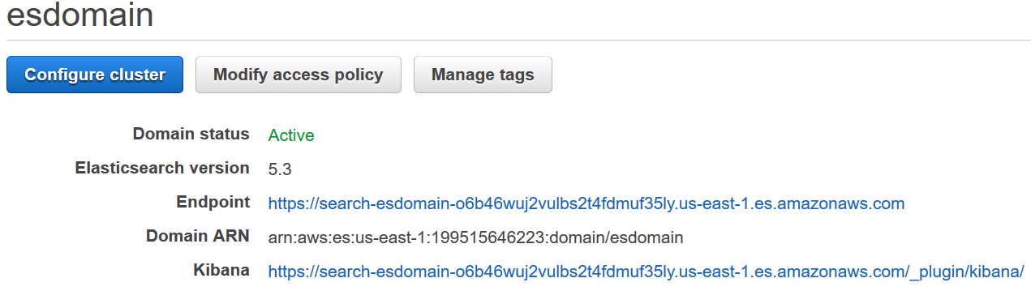

Figure ‑: ES Domain Page

Open the link, create an index name as this is the first login to Kibana.

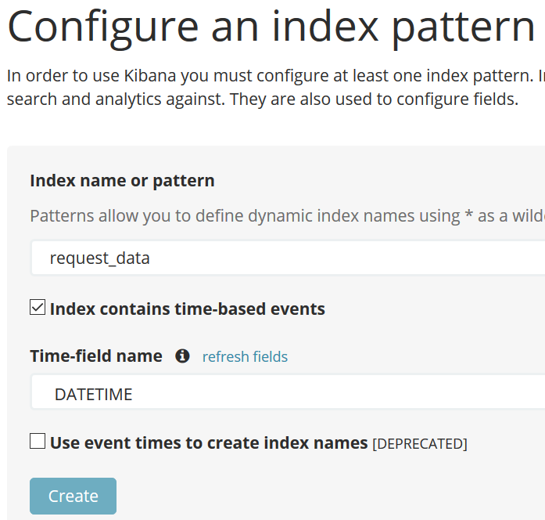

Figure ‑: Creating an Index Pattern on Kibana

We can update the aggregations, change the view of the visuals and discover the data in multiple forms and filter it as per our requirement.

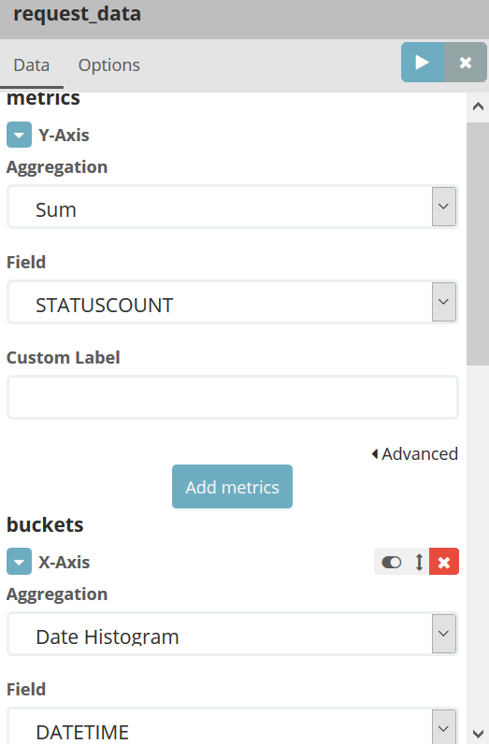

Figure ‑: Configuring the Aggregations on Kibana for Visualization

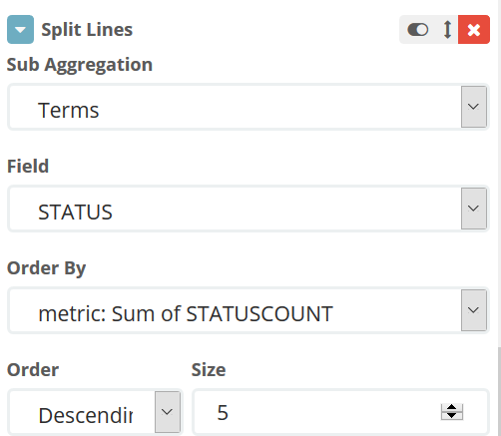

Figure ‑: Configuring the Aggregations on Kibana for Visualization

The Kibana visualization for the selected filters looks like:

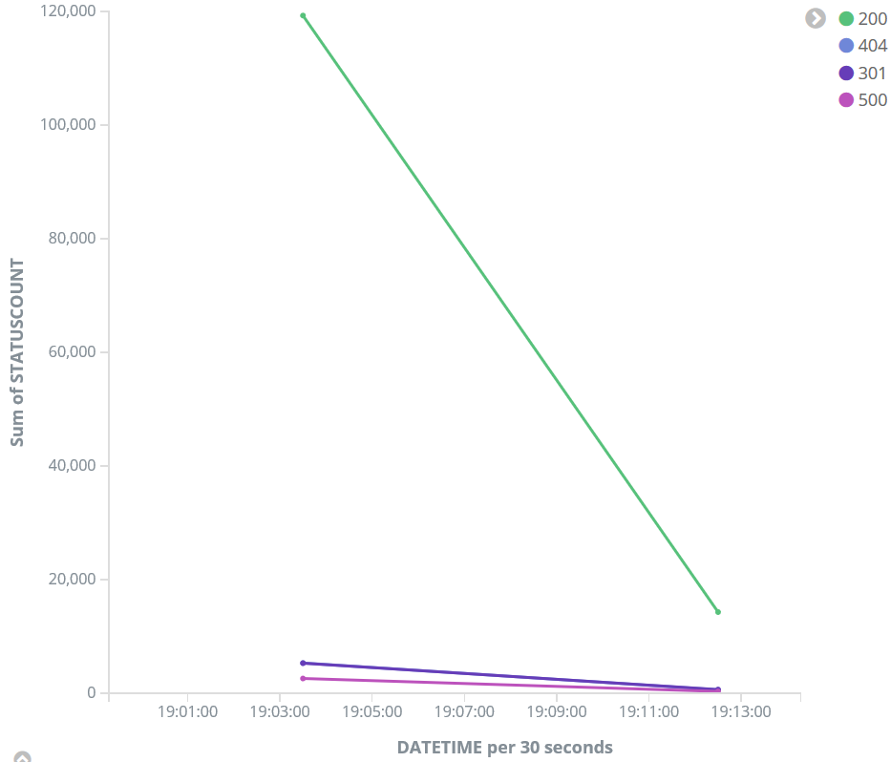

Figure ‑: Kibana Visualization for Streaming Real-Time Data

This step completes the log ingestion, streaming, analysis and visualization of the Apache Access log data.

# 4. CONCLUSION

This project covers a broad spectrum of what Elasticsearch is and how it works on data search. How Elasticsearch is implemented to work with Hadoop and Kibana is first learned in this research. Elasticsearch authorizes a quick insight of the data, which can be in any form in the Hadoop Ecosystem. Elasticsearch provides a full-text search capability by indexing the data and querying it.

The ES-Hadoop library stands as a bridge between Elasticsearch and Hadoop and binds them together to execute real-world scenarios. We worked on diverse types of data in diverse ways to explore how Elasticsearch can be implemented and used along with different tools including Apache Storm, Pig, Hive and so on. With a locally configured CentOS 7 workstation running with Hadoop and Elasticsearch, we could successfully learn, implement and demonstrate these functionalities.

AWS is the most dominant public cloud platform, and it provides a powerful and comprehensive infrastructure for data analytic applications. So, we chose AWS to explore how Elasticsearch can be used in the cloud. We created an AWS instance which allows us to setup an environment for real-time log streaming, analysis and visualization. We used Kinesis Firehose, Kinesis Analytics, Kinesis Agent, S3, Elasticsearch, and Kibana to construct a complete data analytic pipeline which involves streaming Apache Access logs, performing data analysis and aggregation with AWS Elasticsearch, and data visualization using Kibana.

By working on this research project, I gained a great deal of knowledge about data analytics, Elasticsearch, Hadoop and AWS, which are all very important technologies for today’s business world.

# 5. FUTURE WORK

This project can be considered as an initial step to learn about the combination of data analysis, Elasticsearch, Kibana, Hadoop and AWS. Here we implemented all these services and built a data analytics solution which streams real-time data. This project can be taken to the next level by performing multiple analytics, using various other strong tools and services that are available. Anomaly detection and trend analysis can be performed on the streaming data. We can also enlarge data warehouses by adding full-text search and data discovery. More advanced tools like Apache Kafka can be used to implement the Elasticsearch mechanisms and analyze real-time data in a more profound way. Elasticsearch can also be ingested to detect cybercrimes from the log actions and take preventive measures to eradicate them.

# REFERENCES

1. <https://en.wikipedia.org/wiki/Log_analysis>
2. <http://searchitoperations.techtarget.com/definition/log-management>
3. <https://en.wikipedia.org/wiki/Web_log_analysis_software>
4. <https://en.wikipedia.org/wiki/Elasticsearch>
5. <http://0-proquest.safaribooksonline.com.library.nsu.edu/book/databases/hadoop/9781785288999/elasticsearch-for-hadoop/index_html?query=((Elasticsearch+for+Hadoop))#snippet>
6. <https://wikitech.wikimedia.org/wiki/Logstash>
7. <https://aws.amazon.com/>
8. <https://d0.awsstatic.com/Projects/P4113850/aws-projects_build-log-analytics-solution-on-aws.pdf>
9. <http://storm.apache.org/releases/1.1.0/Concepts.html>
10. <https://pig.apache.org/>
11. <https://en.wikipedia.org/wiki/Apache_Hive>